Multifunction Process Calibrator with HART Communication
Statement: this manual is applied to both HART type and Basic type multifunction process calibrators. Illustrations concerned with HART operations can be applied only to HART type. All explanations and examples are made on HART type.
- Introduction
Multifunction process calibrator (as the Calibrator for short) is a hand-hold portable calibrator powered by batteries / Charger, and can measure and source electrical paracalibrators and physical paracalibrators (See Table 1).
Table 1. List for Source and Measurement Functions
Measurement Functions  Source  Functions |  | DCV | DCI |  | OHM | FREQ | TC | RTD | PULSE | PRESSURE | CONTACT
 |  | DCV | LOOP OFF | LOOP ON
DCV |  | ● | ● | ● | ● | ● | ● | ● | ● | ● | ●
DCI | ------ | ● | ● | ● | ● | ● | ● | ● | ● | ● | ●
DCI | RAMP ON | × | × | × | × | × | × | × | × | × | ×
DCI | AUTO STEP ON | ● | ● | ● | ● | ● | ● | ● | ● | ● | ●
OHM |  | ● | ● | ● | ● | ● | ● | ● | ● | ● | ●
FREQ |  | ● | ● | ● | ● | × | ● | ● | × | × | ●
PULSE |  | ● | ● | ● | ● | × | ● | ● | × | × | ●
CONTACT |  | ● | ● | ● | ● | × | ● | ● | × | × | ●
TC |  | ● | ● | ● | ● | ● | × | × | ● | ● | ●
RTD |  | ● | ● | ● | ● | ● | × | × | ● | ● | ●
PRESSURE |  | ● | ● | ● | ● | × | ● | ● | × | × | ●
The Calibrator processes the following features expect the above-mentioned:
- Any function state can enter into HART function directly (only for HART type)
- Measurement and sourcing can work simultaneously. Measured information and soured information display separately
- Thermal couple (TC) input/output terminals and the internal process automatic temperature compensation reference node
- Manual step sourcing, auto step and ramp current sourcing
- Indoor temperature monitor in any operation
- Measurement/ output temperature monitor function
- Measurement/ sourcing mA% display
- Measurement filtering function
- Measurement manual hold function
- Auto-hold function of sourced pressure value display

- Contact Us
To purchase parts, obtain operation help or address of the vendor or service center nearest to you, please call us or visit our web (see the bottom page of the Manual).
- Standard Accessories
Make sure that the package contains all the accessories listed below. And if you find they are damaged or any of them is missing, please contact the vendor from which you purchased the product as soon as possible. Refer to the replacing part list in 15.3 in the Manual if you want to order the replacing parts.

- One pair of Testing Probe（H000000-00）
- One pair of Industrial testing Lead（H000001-00）
- One pair of Industrial testing Lead （H000002-00）
- One pair of hook Testing Probe （H000004-00）
- One pair of Alligator clip（H010000-00）
- One pair of Alligator clip（H010007-00）
- One set of RTD Convertor（H200000-00）
- One copy of A User's Manual
- One copy of Certification of Warranty
- Two pieces of Fuse Tube（100mA/250V）
- Two pieces of Fuse Tube（50mA/250V）
- Four alkaline batteries
- One Bag

- Safety Information
For the correct and safe use of the calibrator, be sure to follow the cautionary notes stated in this manual whenever handling the calibrator. The Company shall not be held liable for any damage resulting from use of the calibrator in a manner other than prescribed in the cautionary notes.Warning identifies conditions and actions that pose hazards to the user; a Caution identifies conditions and actions that may damage the calibrator or the equipment under test.Refer to Table 2 for the explanation of the international electric symbols adopted by the calibrator or the user’s manual.
Table 2 Explanations of International Electrical Symbols
 | EARTH GROUND |  | WARNING INFORMATION

Warning
To avoid possible electric shock or personal injury:
- Do not apply more than the rated voltage, as marked on the calibrator, between terminals or between any terminal and earth ground;
- Before use, verify the calibrator’s operation by measuring a known voltage;
- Follow all equipment safety procedures;
- Do not connect the probe of the testing lead with any live power when the other end has been inserted into the current jack;
- Do not use the calibrator if it is damaged. Before using the calibrator, inspect the case. Look for cracks or missing plastic .Pay particular attention to the insulation surrounding the connectors;
- Select the proper function and range for the measurement;
- Make sure the battery door is closed and latched before operating the calibrator;
- Remove test leads from the calibrator before opening the battery door;
- Inspect the test leads for damaged insulation or exposed metal. Check test lead continuity. Replace damaged test leads before using the calibrator;
- When using the probes, keep fingers behind the finger guards on the probes;
- Connect the common test lead before connecting the live test lead. When disconnecting test leads, disconnect the live test lead first;
- Do not use the calibrator if it operates abnormally. Protection may be impaired. When in doubt, have the calibrator inspect;
- Do not operate this calibrator in areas where inflammable or explosive gases or vapor exists. It is extremely hazardous to use the calibrator under such environments;
- Do not operate the calibrator around explosive gas, vapor, or dust;
- When use the pressure module, do make sure the process pressure line is shut off and depressurized before connecting or disconnecting the pressure module;
- Use only four of type AAA batteries, properly installed in the calibrator case, to power the calibrator;
- Do disconnect the testing lead before shifting to different source or measurement functions;
- When servicing the calibrator, use only specified replacement parts.
- To avoid false reading, which could lead to possible electric shock or personal injury, replace the batteries as soon as the low battery indicator () appears.

Caution
To avoid possible damage to calibrator or to equipment under test:
- Disconnect the power and discharge all high-voltage capacitors before testing resistance or continuity.
- Use the proper jacks, functions, and ranges for the measurement or source operation.

- Familiar With the Calibrator
Figure 1 Entire Graph Figure 2 Measurement/ Source Terminals

  - Measurement/ Source Terminals
Figure 2 shows the measurement /source terminals of the calibrator. Table 3 explains their use.
Table 3 Measurement/ Source Terminals
Terminal | Function
3W terminals：3-wired OHM、RTD measurement input terminals；
LOOP terminals：+24VDC loop power terminals
 | All the common (return ) （-）terminals of measurement function
Input Signals（+）：DcmA；
4- wired OHM、RTD measurement input terminals
 | input signals（+）：DCV、OHM、FREQ、TC、RTD、SWITCH、HART
 | Source signals（+）：（+）DCmA
 | Source signals（+）： OHM、RTD
⑦ | All the common (return ) （-）terminals of measurement function
⑧ | Source signals（+）（+）DCV、OHM、TC、RTD、FREQ、CYC、SWITCH  Source signals（+）（-）DCmA

  - Keys
Figure 3 shows keys of the calibrator. Table 4 explains their use.

Figure 3 keys
Table 4 Functions of the keys
No. | Name | Function
1-4 | Functional keys | operate the TFT display of the calibrator
5 | 2ndF key | select the second function of the press key
6 | power key | connect or disconnect with the power
7 | CONFIG key | enter into the setting interface
8 | SAVE key | store the present data
9 | MERSURE/SOURCE key | shift between measurement function and source function
10 | START key | press the key to start or stop sourcing when the soured current sourcing is in auto-step or auto-ramp mode
11 | HART key | in measurement state, press the key and enter into HART mode to start HART communication(only available to VCHART type, non-available to VC basic )
12 | HOLD key | measurement reading hold; release the locked pressure readings soured pressure measurement
13 | ENTER key | Execution key, execution of the selected operation
14 | ZERO key | source/ zero sourced value
15 | ON/OFF key | start or shut source
16 | EXIT key | exit key, exit from the selected operation
17 | Source set key | decrement of the source set digit
18 | Source set key | left shift of the source set digit
19 | Source set key | right shift of the source set digit
20 | Source set key | increment of the source set digit
- Preparation for Operation
- Operating Precautions
Precautions for Safe Use of the Calibrator
- Be sure to read the instructions given in Section Four “Precautions for Safe Use of the Calibrator.” when using the calibrator for the first time.
- Do not open the calibrator’s case.
Contact the vendor from which you purchased the calibrator, for a service of inspecting or adjusting the internal assembly.
- In case of failure
Should the calibrator begin to emit smoke, give off an unusual odor, or show any other anomaly, immediately turn off the POWER key. If you are using a Charger, disconnect the plug from the wall outlet. Also cut off power to the object under test that is connected to the input terminals. Then, contact the vendor from which you purchased the calibrator.
- General Handling Precautions
- Before carrying around the calibrator turn off power to the object under test, and then the POWER key of the calibrator. If you are using a Charger, disconnect the power cord from the wall outlet. Finally, detach all lead cables from the calibrator. Use a dedicated carry case when transporting the calibrator.
- Do not bring any electrified object close to the input terminals, since the internal circuit may be destroyed.
- Do not apply any volatile chemical to the calibrator’s case or operation panel. Do not leave the calibrator in contact with any product made of rubber or vinyl for a prolonged period. Be careful not to let a soldering iron or any other heat-emitting object come into contact with the operation panel, as the panel is made of thermoplastic resin.
- Before cleaning the calibrator’s case or operation panel, disconnect the power cord plug from the wall outlet if you are using a Charger. Use a soft, clean cloth soaked in water and tightly squeezed to gently wipe the outer surfaces of the calibrator. Ingress of water into the calibrator can result in malfunction.
- If you are using a Charger with the calibrator and will not use the calibrator for a prolonged period, disconnect the power cord plug from the wall outlet.
- For handling precautions regarding the batteries, see “Installing or Replacing the Batteries”.
- For handling precautions regarding the fuses, see “Installing or Replacing the Batteries”.
- Never use the calibrator with the cover of the battery holder opened.
- Environmental Requirements
Use the calibrator in locations that meet the following environmental requirements:
- Ambient temperature and humidity
Ambient temperature range: 0 to 50℃
Ambient humidity range: 20 to 80% RH. Use the calibrator under non-condensing condition.
- Flat and level locations
- Do not use the calibrator in locations that are
- Exposed to direct sunlight or close to any heat source.
- Exposed to frequent mechanical vibration.
- Close to any noise source, such as high-voltage equipment or motive power sources.
- Close to any source of intensive electric or electromagnetic fields.
- Exposed to large amounts of greasy fumes, hot steam, dust or corrosive gases.
- Exposed to unstable or a risk of explosion due to the presence of flammable gases.
Note:
- Use the calibrator under the following environmental conditions if precise source or measurement is your requirement:
Ambient temperature range: 23±5°C; Ambient humidity range: 20 to 80% RH(non-condensing)
When using the calibrator within a temperature range of 0 to 18°C or 28 to 50°C, add a value based on the temperature coefficient shown in Chapter 18“Specifications” to the given accuracy rating.
- When using the calibrator at an ambient humidity of 30% or lower, prevent electrostatic charges from being produced, by using an antistatic mat or any other alternative means.
- Condensation may occur if you relocate the calibrator from places with low temperature and humidity to places with high temperature and humidity, or if the calibrator experiences any sudden temperature change. In that case, leave the calibrator under the given ambient temperature for at least one hour to ensure that the calibrator is free from condensation, before using the calibrator.
- Installing or Replacing the Batteries
Warning
- To avoid electrical shock, always remove the source or measurement lead cables from the object under test, as well as from the calibrator itself.
Caution
- To avoid the risk of fluid leakage or battery explosion, install batteries with their positive and negative electrodes correctly positioned.
- Do not short-circuit the batteries.
- Do not disassemble or heat the batteries or throw them into fire.
- When replacing batteries, replace all of the four batteries at the same time with new ones from the same manufacturer.
- If the calibrator will not be used for a prolonged period, remove the batteries from the calibrator.
Step 1: Remove the lead cables and charger and turn off the calibrator before beginning installing batteries.
Step 2: Remove the battery holder cover by sliding it in one-quarter counterclockwise direction and turn off the calibrator.
Step 3: Install four alkaline batteries of same type in the battery holder with their positive and negative electrodes positioned correctly as indicated on the holder.
Step 4: After replacement, reattach the battery holder cover.

Figure 4-1

Indication of Battery Level
The battery replacement indicator shows the battery level in five types according to the measured voltage of the batteries.
Full battery:
The battery level is below 50% full:
The battery level is below 25% full:
Low battery:
Note that the battery replacement indicator is driven by directly measuring the battery voltage when the calibrator is in actual operation. Consequently, the indicator may read differently depending on the battery load condition (e.g., the load condition of the source output or on/ off state of the measurement function) if the batteries are too low.
If the calibrator will be used under a wide variety of conditions, it is advisable that the battery replacement indicator be verified under heavy loads (MEASURE mode is on and the SOURCE mode is set to the 20 mA/10 V output).
- Replacing the Fuse
Warning
To avoid possible electric shock, remove the test leads from the calibrator before open the battery door. The specification of fuse is 100mA/250V fast-belt fuse.
Replace the fuse as follows:
- Remove the test leads before replacing batteries or fuse, and turn off the calibrator;
- Remove the protector (the same as shown in “Replacing the Batteries”);
- Replace the blown fuses with same type;
- Reinstall and tighten the battery door (the same as shown in “Replacing the Batteries”).
Figure 4-2
Warning
- Make sure the voltage of the AC power source matches the rated supply voltage of the Charger, before connecting the Charger to the AC power source.
- Do not use any Charger other than the dedicated Charger from the Company.
Step 1: Make sure the calibrator is turned off.
Step 2: Insert the plug of the optional Charger into the Charger connection jack.
Note:
Turn off the calibrator before connecting or disconnecting the Charger from AC power, plugging in/out the Charger connection jack.
- Turning On/off the Power
- Power On/off
Pressing the Power key once and hold for 3 seconds to turn on the calibrator; repress the Power key and hold for 3 seconds to turn off the calibrator.
Note
To make sure correct electronic operation, wait for 5 seconds before turn on the calibrator again.
- Automatic Power-off
When the calibrator is running on batteries and no key is operated for approximately ten minutes, the calibrator turns off automatically. The automatic power-off time could be reset in the factory default parts.

- Set the Menu
Press CONFIG key to enter into setting interface
There are two screens in setting menu, and ten items altogether
Specified operations for each setting are shown as follows:
- Press []/[] key, select this option;
- Press ENTER key to enter into setting interface;
- Press []/[] key to adjust to needed parameters;
- Press SAVE key to preserve setting;
- Press EXIT key to exit from setting.
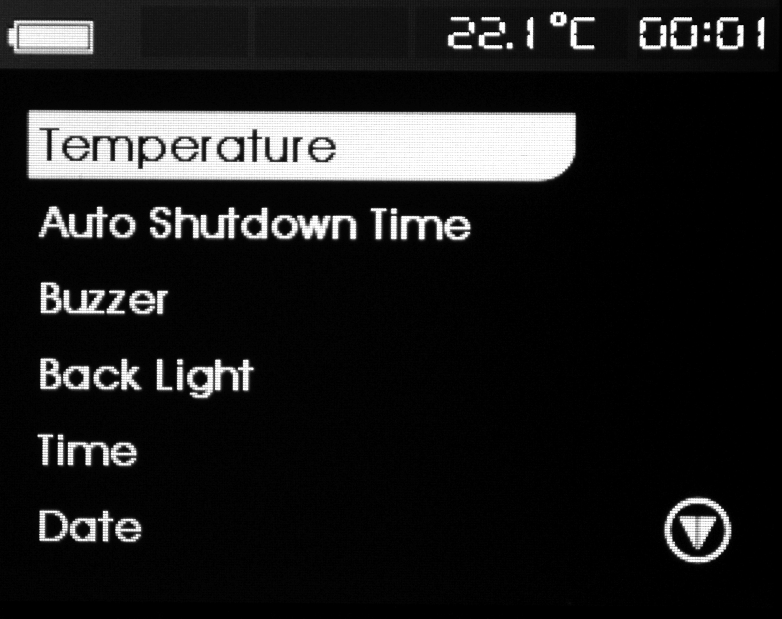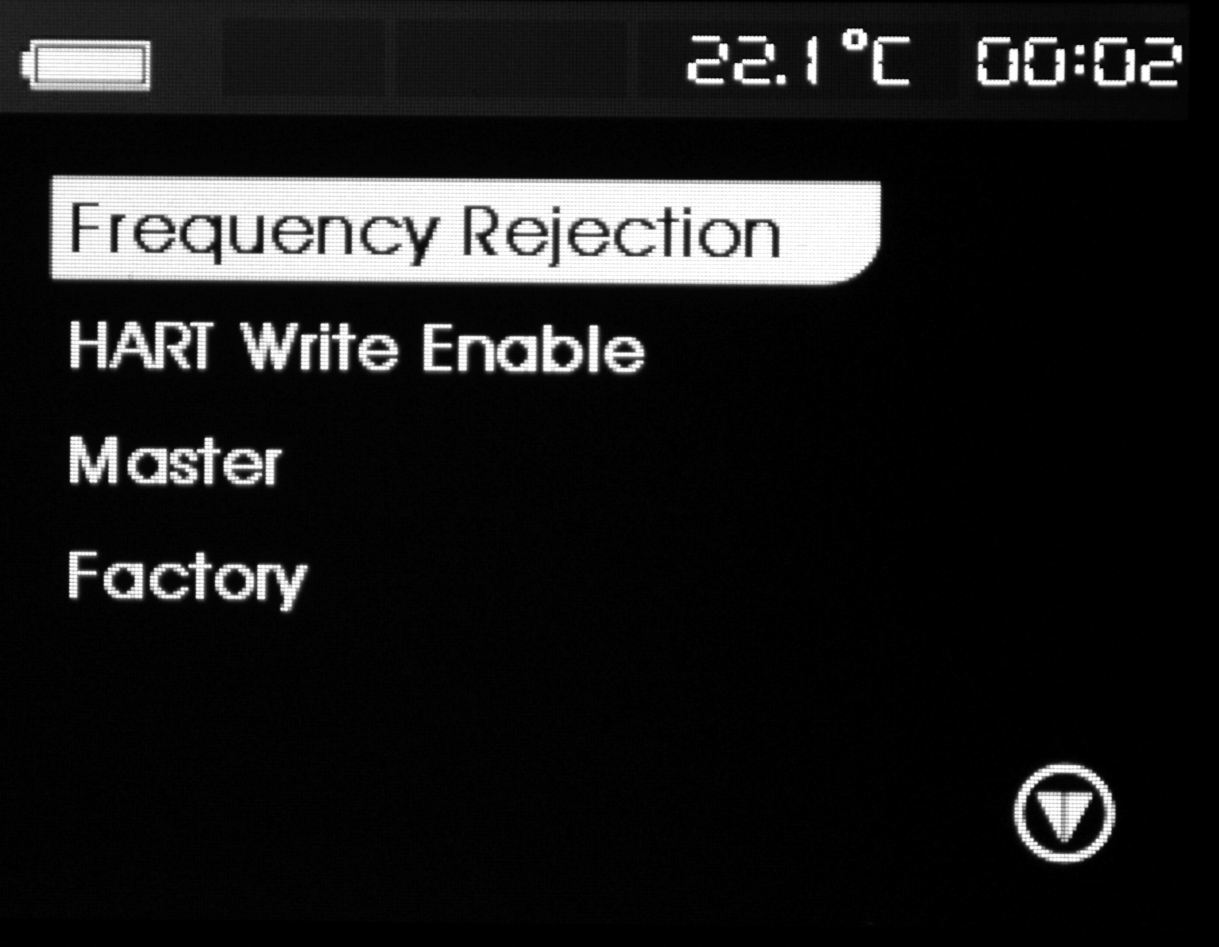
Temperature compensation setting
The first option of the set menu is temperature compensation setting, which is used to make a reference for temperature compensation when the calibrator sources TC.
Auto-power off time
The second option in the calibrator setting menu is used to set auto-power off time, which is used to set the waiting time for no operation. The time can be set from 0 minutes to 30 minutes and 0 minutes denotes cancelling auto-power off function.
Beeper Enable
The third option in the calibrator setting menu is used to set beeper enable,
Backlight setting
The fourth option in the calibrator setting menu is used to set backlight of TFT screen, which is used to set high or low light of the backlight.
Systematic time setting
The fifth option in the calibrator setting menu is used to set systematic time, and the set time is displayed in the upper right part of the screen.
Systematic date setting
The sixth option in the calibrator setting menu is used to set systematic date.
Power frequency setting
The seventh option in the calibrator setting menu is used to set power frequency, which is used to set power frequency restrain.
HART write enable (only for HART type)
The eighth option in the calibrator setting menu is used to start or close the HART write; when in starting mode, LRV and URV operations are allowed while in closing mode, LRV and URV operations are prohibited.
HART main frame setting（only for HART type）
The ninth option in the calibrator setting menu is used to set HART main frame, which is used to select HART main frame; the HART main frame is divided into first HART main frame and second HART frame.
Restore to factory default
The tenth option in the calibrator setting menu is factory default setting, which is used to choose whether to restore to factory default or not.

- Source Mode
After power on the calibrator, the measurement and source display in the same screen, the upper part of the TFT screen is for measurement and the lower part of the TFT screen is for source; press [SOURCE/MEASURE] key to shift between measurement and source.
From the calibrator, you can source a DC voltage, DC current, resistance, thermocouple, RTD, frequency, pulse number or switch signal.
Warning
To avoid electrical shock, do not apply more than the rated voltage, as marked on the calibrator, between terminals or between any terminal and earth ground. Always use the calibrator in locations with a voltage to ground below 30 V.
Caution
Do not apply any voltage to the output terminals for ranges other than 4-20mA simulating transmitter output; otherwise the internal circuitry may be damaged.
The calibrator has been calibrated without taking into account a voltage drop due to the resistance component of the lead cables for source. Care must be taken therefore when drawing a load current since the voltage drop due to the resistance component (approximately 0.1 Ω on a round-trip basis) of the lead cables serves as an error.

  - Connecting Cables to Terminals
For DC voltage, thermocouple, frequency, pulse or switch (Figure 5)
Step 1: Connect the black lead cable for source to the COM output terminal and the red lead cable to the “VhzTcmA-” output terminal.
Step 2: Connect the other ends of the cables to the input of equipment under test while making sure the polarities are correct.

Figure 5 Sourcing DC voltage, TC, frequency, pulse and switch
For DC current (Figure 6)
Step 1: Connect the black lead cable for source to the “VhzTcmA-” output terminal and the red lead cable to the ‘’mA+’’ output terminal.
Step 2: Connect the other ends of the cables to the input of equipment under test while making sure the polarities are correct.

Figure 6 Sourcing DC Current
For resistance and RTD signal (Figure 7)
Step 1: Connect black lead cables for source to the ‘’Ω, RTD’’ terminal and the red lead cable to the “VhzTcmA-” terminal.
Step 2: Connect the other ends of the cables to the input of equipment under test while making sure the polarities are correct.

Figure 7 Sourcing Resistances and RTD

  - Sourcing DC Voltage
Step 1: Using the Function selector switch〔F1〕to select DC voltage source function, select the desired range from 100mV, 1V, and 10V by pressing the〔F2〕key.
Step 2: Set the output value digit by digit using Source keys.
The〔〕/〔〕key is to change the setting position, Each press of the〔〕/〔〕key shifts the setting position one digit; Each press of the 〔〕/〔〕key increases or decreases the digit. Increasing the digit from 9 or decreasing it from 0 causes the digit to overflow or underflow, allowing you to set the output value without interruption. Holding down the 〔〕/〔〕key continuously changes the digit in question. And the value won’t change if it is increased or decreased to the Maxim or Minimum value. Pressing the〔ZERO〕key initializes the output set point to the default value (0).
Step 3: Pressing the〔ON〕key causes the indicator on the LCD to change from ‘’OFF‘’ to ‘’ON ‘’. The calibrator sources the preset DC voltage between the output terminals.
Step 4: To turn off the output, press the〔ON〕key once again. The’’ OFF ‘’ appears on the LCD and no signals sourced between the terminals.

  - Sourcing DC Current
Step 1: Using the Function selector switch〔F1〕to select DC current source function.
Step 2: Using〔F2〕key to select DC current sourcing span.
Current sourcing span: 0-20mA and 4-20mA.
Step 3: Set the output value digit by digit using Source keys.
The〔〕/〔〕key is to change the setting position, Each press of the〔〕/〔〕key shifts the setting position one digit; Each press of the 〔〕/〔〕key increases or decreases the digit. Increasing the digit from 9 or decreasing it from 0 causes the digit to overflow or underflow, allowing you to set the output value without interruption. Holding down the 〔〕/〔〕key continuously changes the digit in question. And the value won’t change if it is increased or decreased to the Maxim or Minimum value. Pressing the〔ZERO〕key initializes the output set point to the default value (0).
Step 4: Pressing the〔ON〕key causes the indicator on the SOURCE LCD to change from ‘’OFF‘’ to ‘’ON ‘’ . The calibrator sources the preset DC current between the output terminals.
Step 5: To turn off the output, press the〔ON〕key once again. The’’ OFF ‘’ appears on the LCD and no signals sourced between the terminals.

    - 25% step current sourcing
Step 1: In DC current function, press the〔F3〕key to display “25%” on the lower part of the screen. The default source value will be showed simultaneously.
Step 2: press the 〔〕key, the current sources from 0% and steps in 25% and increase to 100%.
Among which: 100% corresponds to 20mA; 0% corresponds to 0 mA or 4mA ; which are depends on the setting of current span; relevantly, 25% step corresponds to 5mA or 4mA.
Step 3: Pressing the〔ON〕key causes the indicator on the LCD to change from ‘’OFF‘’ to ‘’ON ‘’. The calibrator sources the preset current signal between the output terminals.
Step 4: To turn off the output, press the〔ON〕key once again. The’’ OFF ‘’appears on the LCD and no signals sourced between the terminals.
    - 100% step current sourcing
Step 1: In DC current function, press the〔F3〕key to display “100%” on the lower part of the screen. The default source value will be showed simultaneously.
Step 2: press the 〔〕key, the current sources from 0% and steps in 100% and increase to 100%.
Among which: 100% corresponds to 20mA; 0% corresponds to 0 mA or 4mA ; which are depends on the setting of current span.
Step 3: Pressing the〔ON〕key causes the indicator on the LCD to change from ‘’OFF‘’ to ‘’ON ‘’. The calibrator sources the preset current signal between the output terminals.
Step 4: To turn off the output, press the〔ON〕key once again. The’’ OFF ‘’appears on the LCD and no signals sourced between the terminals.
    - Auto-ramping Sourcing
Step 1: In DC current function, press〔F3〕key to display signal “” on the left part of the screen, and the default source value will be showed simultaneously.
Step 2: Pressing the〔〕/〔〕key to adjust the ramping time , and the range is within 5-60 seconds.
Step 3: Pressing the〔ON〕key causes the indicator on the LCD to change from ‘’OFF‘’ to ‘’ON ‘’.
Step 3: Pressing the〔START〕key starts the auto-ramping mode. The “RUN” mark displays on the left part of the screen.
Step 4: Pressing the〔START〕key once more stops the auto-ramping mode. “STOP’ mark displays on the left part of the screen. The terminals source the value displayed on the screen.
Step 5: Repressing the〔ON〕key stops sourcing, ‘’OFF’’ mark displayed on the screen. No signals sourced between the terminals.
    - Auto-stepping Sourcing
Step 1: In DC current function, press 〔F3〕key to display signal “” on the lower part of the screen, and the default source value will be showed simultaneously.
Step 2: Pressing the〔〕/〔〕key to adjust the stepping time , and the range is within 5-60 seconds.
Step 3: Pressing the〔ON〕key causes the indicator on the LCD to change from ‘’OFF‘’ to ‘’ON ‘’.
Step 3: Pressing the〔START〕key starts the auto-stepping mode. “RUN “mark displays on the left part of the screen.
Step 4: Pressing the〔START〕key once more stops the auto-stepping mode. “STOP“mark disappears. The terminals source the value displayed on the screen.
Step 5: Repressing the〔ON〕key stops sourcing, ‘’OFF’’ mark displayed on the screen. No signals sourced between the terminals.
Tips:
- Press the 〔START〕key again to continue the auto-stepping and auto-ramping mode after stopping them, and “RUN” mark displays on the lower part of the screen.
- Using the〔START〕key to start mA auto-stepping and auto-sweeping mode is only available when the source function is in ON state.
    - 0-20 mA simulate transmitter source
Figure 8. 0--20 mA simulate transmitter source
Operation is the same with the steps as shown in sourcing DC current.
  - Sourcing Resistance
Figure 9. Connection method based on three-wire and four-wire
- Firstly, the calibrator sources a resistance signal by receiving the resistance-measuring current I supplied from the device being calibrated (such as a resistance calibrator) and then delivering the voltage V proportional to the preset resistance R between the output terminals, and thus producing the equivalent resistance R =V/I. Consequently, the calibrator sources the signal correctly only for such devices that employ this method of measurement.
- The allowable range of the resistance measuring current I that the calibrator receives from a resistance measuring device under calibration is rated as 0.1 mA to 3 mA. To ensure accuracy, the resistance measuring current I from the device under calibration shall be strictly confined within the range.
- Any resistance signal being sourced does not include the resistance component of the lead cables for source. The whole resistance, when measured at the ends of the lead cables for source, is given by adding the resistance of the lead cables (approximately 0.1Ω on a round-trip basis) to the sourced resistance signal. For source of precise resistance signals, use three-wire or four-wire connection.
- If capacitance between the terminals of a device under calibration is greater than 0.1ųF, the calibrator may fail to source correct resistance signals.
Step 1: Using the function selector switch 〔F1〕, select Ohm function. Using the 〔F2〕key, select the desired range. Using the 〔F3〕key select the proper simulate current range.
There are two ranges as 400Ω and 4KΩ for resistance source, the simulate currents of 400Ω range corresponds to 0.1mA and 1mA ranges; 4KΩ range corresponds to 0.1mA range.
The valid range of 0.1mA simulate current range is: 0.03~0.3mA; when the simulate current of the external input is higher than 0.3mA, li_LO symbols displays in the upper right part of the calibrator; when the simulate current of the external input is between 0.03mA and 0.3mA , li_ok symbols displays in the upper right part of the calibrator; The valid range of 1mA simulate current range is: 0.3~3mA; when the simulate current of the external input is higher than 0.3mA, li_Hi symbols displays in the upper right part of the calibrator; when the simulate current of the external input is between 0.3mA and 3mA , li_ok symbols displays in the upper right part of the calibrator.
Step 2 :Set the output value digit by digit using each pair of〔〕/〔〕keys.
The〔〕/〔〕key is to change the setting position, Each press of the〔〕/〔〕key shifts the setting position one digit; Each press of the 〔〕/〔〕key increases or decreases the digit. Increasing the digit from 9 or decreasing it from 0 causes the digit to overflow or underflow, allowing you to set the output value without interruption. Holding down the 〔〕/〔〕key continuously changes the digit in question. And the value won’t change if it is increased or decreased to the Maxim or Minimum value. Pressing the〔ZERO〕key initializes the output set point to the default value (0).
Step 3: Pressing the〔ON〕key causes the indicator on the LCD to change from ‘’OFF‘’ to ‘’ON ‘’, The terminals source the value displayed on the screen.
Step 4: Repressing the〔ON〕key stops sourcing, ‘’OFF’’ mark displayed on the screen. No signals sourced between the terminals.
  - Connection method based on three-wire and four-wire as shown in Figure 9
  - Simulate Sourcing TC
The calibrator is designed with an internal temperature sensor. To calibrate a device with built-in reference junction temperature compensation by sourcing a thermoelectromotive force with the calibrator without using non-external 0℃ reference junction compensation means, use the RJ sensor function. Select simulate TC source function, in which RJ senor goes on work automatically. The “RJ-ON” mark displays on the middle part of the screen.
Step 1: Using the function selector switch〔F1〕, select simulate TC source function. Using the〔F2〕key, select the desired range from K，E，J，T，N，B，L，U，R，S. The selected TC mark shall be shown in the right part of the LCD , the default range source value and unit shall be shown in the middle part.
Step 2 : Press the〔F3〕key to select temperature compensation type.
Temperature compensation type: non- compensation (RJ-OFF displays in the lower left part of the screen).
Take the temperature input by the User as a reference (the temperature set by the User in the lower left part of the screen).
See chapter seven for setting the referenced temperature by the User.
Take the measured temperature of the calibrator’s temperature module (RJ-OFF displays in the lower left part of the screen).
Step 3 : Press the〔F4〕key to select TC unit.
Step 4 :Set the output value digit by digit using each pair of〔〕/〔〕keys.
The〔〕/〔〕key is to change the setting position, Each press of the〔〕/〔〕key shifts the setting position one digit; Each press of the 〔〕/〔〕key increases or decreases the digit. Increasing the digit from 9 or decreasing it from 0 causes the digit to overflow or underflow, allowing you to set the output value without interruption. Holding down the 〔〕/〔〕key continuously changes the digit in question. And the value won’t change if it is increased or decreased to the Maxim or Minimum value. Pressing the〔ZERO〕key initializes the output set point to the default value (the default value of a typical B type is 600℃).
Step 5: Pressing the〔ON〕key causes the indicator on the LCD to change from ‘’OFF‘’ to ‘’ON ‘’ . A thermoelectromotive force based on the temperature detected by the RJ sensor develops between the output terminals.
Step 6: To turn off the output, press the〔ON〕key once again. The ‘’OFF‘’ appears on the LCD and no signals sourced between the terminals.
Tips:
- The TC source function is unavailable if the TC /RTD measurement function is on, which is only usable when the calibrator is in non-TC or RTD measurement function.
    - Temperature Monitor Function
The calibrator offers a temperature monitor function, which is convenient for the user to observe the voltage value sourced between the output terminals in TC source function.
In TC source function, LCD shows the voltage value sourced between the output terminals and the sourced voltage in the same screen.
  - Sourcing RTD
- The principle of RTD sourcing is the same as resistance sourcing.
- The allowable range of the resistance measuring current I in terms of type Pt100、Cu50、Cu10 that the calibrator receives from a resistance measuring device under calibration is rated as 0.1 to 3 mA . The allowable range of the resistance measuring current I in terms of Pt200、Pt500、Pt1000 that the calibrator receives from a resistance measuring device under calibration is rated as 0.05 to 0.3 mA . To ensure accuracy, the resistance measuring current I from the device under calibration shall be strictly confined within the range. For further details, see Chapter 18, “Specification”.
- Any resistance signal being sourced does not include the resistance component of the lead cables for source. The whole resistance, when measured at the ends of the lead cables for source, is given by adding the resistance of the lead cables (approximately 0.1Ω on a round-trip basis) to the sourced resistance signal. For source of precise resistance signals, use three-wire or four-wire connection.
Step 1: Using the function selector switch〔F1〕, select RTD function. Using the〔F2〕key to select a desired RTD range from PT100, PT200, PT500, PT1000, Cu10, Cu50. The selected function and the default range source value and unit shall be shown in the lower part of the LCD.
Step 2 : Press the〔F3〕key to select simulate current .
Simulate current：0.1mA（Pt100，Pt200，Pt500，Pt1000，Cu10，Cu50）
1mA（Pt100， Cu10，Cu50）
The valid range of 0.1mA simulate current range is: 0.03~0.3mA; when the simulate current of the external input is higher than 0.3mA, li_LO symbols displays in the upper right part of the calibrator; when the simulate current of the external input is between 0.03mA and 0.3mA , li_ok symbols displays in the upper right part of the calibrator; The valid range of 1mA simulate current range is: 0.3~3mA; when the simulate current of the external input is higher than 0.3mA, li_Hi symbols displays in the upper right part of the calibrator; when the simulate current of the external input is between 0.3mA and 3mA , li_ok symbols displays in the upper right part of the calibrator.
Step 3 : Press the〔F4〕key to select RTD unit.
Step 4 :Set the output value digit by digit using each pair of〔〕/〔〕keys.
The〔〕/〔〕key is to change the setting position, each press of the〔〕/〔〕key shifts the setting position one digit; Each press of the 〔〕/〔〕key increases or decreases the digit. Increasing the digit from 9 or decreasing it from 0 causes the digit to overflow or underflow, allowing you to set the output value without interruption. Holding down the 〔〕/〔〕key continuously changes the digit in question. And the value won’t change if it is increased or decreased to the Maxim or Minimum value. Pressing the〔ZERO〕key initializes the output set point to the default value (0).
Step 5: Pressing the〔ON〕key causes the indicator on the LCD to change from ‘’OFF‘’ to ‘’ON ‘’ . The calibrator sources the preset resistance value between the output terminals.
Step 6: To turn off the output, press the〔ON〕key once again. The ‘’OFF‘’ appears on the LCD and no signals sourced between the terminals.
  - Connection method based on three-wire and four-wire as shown in Figure 9
Tips:
The RTD source function is unavailable if the TC /RTD measurement function is on, which is only usable when the calibrator is in non-TC or RTD measurement function.
    - Temperature Monitor Function
The calibrator offers a temperature monitor function, which is convenient for the user to observe the resistance value sourced between the output terminals.
In TC source function, LCD shows the voltage value sourced between the output terminals and the sourced voltage in the same screen.
  - Sourcing Frequency
The calibrator can source a constant pulse signal responding to the preset frequency and amplitude.
Step 1: Press the〔F1〕key to select frequency sourcing function.
Step 2: Press the〔F2〕key to select proper frequency range among 100HZ，1KHz，10KHz，50KHz，CPM .
Step 3 :Set the output frequency value digit by digit using each pair of〔〕/〔〕keys.
The〔〕/〔〕key is to change the setting position, each press of the〔〕/〔〕key shifts the setting position one digit; Each press of the 〔〕/〔〕key increases or decreases the digit. Increasing the digit from 9 or decreasing it from 0 causes the digit to overflow or underflow, allowing you to set the output value without interruption. Holding down the 〔〕/〔〕key continuously changes the digit in question. And the value won’t change if it is increased or decreased to the Maxim or Minimum value.
Step 4 : Press the〔F3〕key to shift to the amplitude set; and set the frequency amplitude digit by digit using each pair of〔〕/〔〕keys.
The〔〕/〔〕key is to change the setting position, each press of the〔〕/〔〕key shifts the setting position one digit; Each press of the 〔〕/〔〕key increases or decreases the digit. Increasing the digit from 9 or decreasing it from 0 causes the digit to overflow or underflow, allowing you to set the output value without interruption. Holding down the 〔〕/〔〕key continuously changes the digit in question. And the value won’t change if it is increased or decreased to the Maxim or Minimum value.
Step 7: Pressing the〔ON〕key causes the indicator on the LCD to change from ‘’OFF‘’ to ‘’ON ‘’ . The calibrator sources constant pulse signals according to the preset frequency , amplitude value between the output terminals.
Step 8: To turn off the output, press the〔ON〕key once again. The ‘’OFF‘’ appears on the LCD and no signals sourced between the terminals.
Tips:
- The frequency source function is unavailable if the frequency and voltage measurement function is on, which is only usable when the calibrator is in non-frequency or voltage measurement function.
- The frequency value and range could be changed when the frequency source function is both in ‘’ON ‘’ or ‘’OFF‘’ state.
  - Sourcing Number of Pulses
The calibrator can source a preset number of pulse signal responding to the preset frequency and amplitude.
Step 1: Press the〔F1〕key to select number of pulse.
Step 2: Press the〔F2〕key to select proper frequency range among 100HZ，1KHz，10KHz.
Step 3 :Set the output number of pulses digit by digit using each pair of〔〕/〔〕keys.
The〔〕/〔〕key is to change the setting position, each press of the〔〕/〔〕key shifts the setting position one digit; Each press of the 〔〕/〔〕key increases or decreases the digit. Increasing the digit from 9 or decreasing it from 0 causes the digit to overflow or underflow, allowing you to set the output value without interruption. Holding down the 〔〕/〔〕key continuously changes the digit in question. And the value won’t change if it is increased or decreased to the Maxim or Minimum value.
Step 4 : Press the〔F3〕key to shift to the amplitude set; and set the pulse amplitude digit by digit using each pair of〔〕/〔〕keys.
The〔〕/〔〕key is to change the setting position, each press of the〔〕/〔〕key shifts the setting position one digit; Each press of the 〔〕/〔〕key increases or decreases the digit. Increasing the digit from 9 or decreasing it from 0 causes the digit to overflow or underflow, allowing you to set the output value without interruption. Holding down the 〔〕/〔〕key continuously changes the digit in question. And the value won’t change if it is increased or decreased to the Maxim or Minimum value.
Step 5 : Press the〔F3〕key to shift to the number of pulse mode ; and set the number of pulse digit by digit using each pair of〔〕/〔〕keys.
The〔〕/〔〕key is to change the setting position, each press of the〔〕/〔〕key shifts the setting position one digit; Each press of the 〔〕/〔〕key increases or decreases the digit. Increasing the digit from 9 or decreasing it from 0 causes the digit to overflow or underflow, allowing you to set the output value without interruption. Holding down the 〔〕/〔〕key continuously changes the digit in question. And the value won’t change if it is increased or decreased to the Maxim or Minimum value.
Step 6: Pressing the〔ON〕key causes the indicator on the LCD to change from ‘’OFF‘’ to ‘’ON ‘’ and sources low electrical level.
Step 7: Pressing the〔START〕key starts the auto-stepping mode. The “RUN “ mark displays on the left part of the screen. The calibrator sources the numbers of the pulse signals according to the preset frequency and amplitude between the output terminals.
Step 8: Pressing the〔START〕key once more stops the auto-stepping mode. The “STOP“ mark appears.
Step 9: Repressing the〔ON〕key stops sourcing, ‘’OFF’’ mark displayed on the screen. No signals sourced between the terminals.
Tips:
- The contact output source function is unavailable if the frequency measurement function is on, which is only usable when the calibrator is in non-frequency measurement function.
- When the “RUN” symbol vanishes from the LCD, you can change the frequency and amplitude both when the source function is in ‘’ON ‘’ or ‘’OFF‘’.
- In the pulse sourcing process, pressing the〔START〕key causes to stop the output, and the “RUN” mark vanishes from the LCD. Press the〔START〕key once more to restart the sourcing function.
- Restarting the pulse output requires the source function is in ‘’ON ‘’state.

  - Sourcing Switch
You can turn on or off the output terminals by using the contact output function. An FET is used as the contact-switching device.
Step 1: Using the function selector switch〔F1〕, select the output source function.
Step 2: Using the〔F2〕key, select the desired frequency from 100Hz, 1KHz, 10 KHz, and 50KHz.
Step 3 : set the frequency digit by digit using each pair of〔〕/〔〕keys.
The〔〕/〔〕key is to change the setting position, each press of the〔〕/〔〕key shifts the setting position one digit; Each press of the 〔〕/〔〕key increases or decreases the digit. Increasing the digit from 9 or decreasing it from 0 causes the digit to overflow or underflow, allowing you to set the output value without interruption. Holding down the 〔〕/〔〕key continuously changes the digit in question. And the value won’t change if it is increased or decreased to the Maxim or Minimum value.
Step 4: Pressing the〔ON〕key causes the indicator on the LCD to change from ‘’OFF‘’ to ‘’ON ‘’ and The calibrator sources the switch signals according to the preset frequency between the output terminals.
Step 5: Repressing the〔ON〕key stops sourcing, ‘’OFF’’ mark displayed on the screen. No signals sourced between the terminals.
Tips:
- The contact output source function is unavailable if the frequency and voltage measurement function is on, which is only usable when the calibrator is in non-frequency or non-voltage measurement function.
- You can change the frequency both when the source function is in ‘’ON ‘’ or ‘’OFF‘’.
- The contact output is polarity. Generally, connect the positive polarity with the H jack of the calibrator and the negative polarity with the L jack.
- Note the maxim allowable current of the contact output is 50mA.
  - Sourcing Pressure
The calibrator source pressure by measuring the pressure from a pump or any other device, and shows the value in the lower part of the LCD. Figure 10 demonstrates how to connect the pump with the pressure module so as to make it into a calibrated source. Ranges and types of the pressure module have various options. See “Accessories” for more information. Due to the difference in medium and accuracy of different pressure modules, user needs to read the Manual before operating it. Follow the steps listed below to source pressure with a proper pressure module (assisted by the tested technical pressure).
Figure 10 Sourcing Pressure

Warning
To avoid a sudden release of the pressure system, do shut off the valve to release the pressure gradually before connecting the pressure module with the pipe.
Caution
To avoid any mechanical damage to the pressure module, do not apply any force higher than 13.5 Nm(10 ft.1bs) to the pressure pipe mouths(or the module and the pipe mouth).Do apply the specified force when connecting the pipe or the Charger.To avoid any damage to the pressure module due to over pressed, do not apply any pressure higher than the maximum value marked or specified.To avoid any corrosive damage, use the pressure module only with specified materials. Refer to the printing on the pressure module or the pressure module instruction sheet for the acceptable material compatibility.
Step 1: Connect the pressure module and calibrator. The screw of the pressure module pipe is compatible to the 1/4 inch NPT connector. If you have other requirement, contact the vendor.
Step 2: Using the function selector switch〔F1〕, select the pressure source function.
Step 3: Pressing the〔ON〕 key turns on the function, the calibrator connects and senses the type of the pressure module and sets the range automatically. If it fails to connect, the LCD shows “n/a”in the lower part.
Step 4: Zero off the reading following the pressure module manual. When the reading overtops the 95 percentage of maxim value of the range, the LCD shows “ERR” in the lower part. Pressing the〔ZERO〕key initializes the calibrator to 0,and “△”symbol shows on the left lower part of the LCD.
Step 5: Apply pressure on the pipe with the pressure source until the desired pressure value displayed on the LCD.
Tips:
    - For absolute pressure module, the calibrator stores the positive value and use the value automatically, thus the User won’t make zero calibration for each use of the module.
    - In pressure source function, the User can not set the pressure value in the screen. When the soured pressure unit is MPa, press〔F4〕to shift between MPa and KPa.
For absolute pressure module, the calibrator saves the zero-off value and reuses the value automatically. Therefore, user does not need to zero off the calibration value for each use.

    - Auto-hold of pressure source HOLD
In pressure source function, when the switch measurement mode is selected, the calibrator preserves pressure value and the switch state on the LCD automatically. Pressing the〔HOLD〕key releases the HOLD mode automatically.
  - Zero-off function
  - In any range of DC voltage, DC current, ohm, TC and RTD functions, pressing the〔ZERO〕key selects clearing off function, which initializes the preset source value for the convenience of user to reset source value.
  - In pressure source function, pressing the〔ZERO〕key clears off the value. For absolute pressure module, the calibrator saves the zero-off value and reuses the value automatically.
  - In frequency, pulse, contact output functions, the〔ZERO〕key is unavailable.
- Measurement
After power on the calibrator, the measurement and source display in the same screen, the upper part of the TFT screen is for measurement and the lower part of the TFT screen is for source; press [SOURCE/MEASURE] key to shift between measurement and source.
From the calibrator, you can measure a DC voltage, DC current, resistance, thermocouple, RTD, frequency, continuity, switch and pressure.
Warning
- In an application where the calibrator is used together with the supplied lead cables for measurement, the allowable voltage to ground of the input terminals is 60 V peak maximum. To avoid electrical shock, do NOT use the calibrator at any voltage exceeding the maximum voltage to ground.
- The allowable voltage to ground when the supplied thermocouple convertor is attached to the input terminals is 60V peak maximum. To avoid electrical shock, do not use the terminal Charger for measuring any circuit voltage exceeding the maximum voltage to ground.
Tips:
- With the〔HOLD〕key, you can hold the measured value.
- The measurement value is updated differently responding to different measurement function. LCD shows “ - - - - - “on the upper part when shifting the range. If the input is over ranged, the measured value on the LCD reads as “oL”.

  - Connecting Cables to Terminals
Figure 11. Measuring DC voltage, Ohms, frequency , continuity and switch
Step 1: Connect the black lead cable for measurement to the “COM” input terminal and the red lead cable to the ”VHzTc ΩRTD” input terminal.
Step 2: Connect the other end of the cable to the measuring terminals of equipment under test while making sure the polarities are correct.
For DC current signal (Figure 12)

Figure 12 Measuring DC current
Step 1: Connect the black lead cable for measurement to the “COM” input terminal and the red lead cable to the ”mA” input terminal.
Step 2: Connect the other end of the cable to the measuring terminals of equipment under test while making sure the polarities are correct.
For thermocouple signal (Figure 13)

Figure 13 Measuring TC
Step 1: Connect the thermocouple convertor to the input terminals. This will help you connect the cables easily.
Step 2: Connect between TC terminals. Connect the positive output lead wire of the thermocouple to the ‘+’ terminal of the thermocouple convertor and the negative output lead wire to the ‘-’ terminal.

Three wire connection method for RTD signal (Figure 14)

Figure 14 RTD signal with 3w method
Step 1: Connect one black lead cable for measurement to the “COM” input terminal and another black lead to the “3W” terminal. Connect the red lead cable to the ” VHzTcΩRTD” input terminal.
Step 2: Connect the three clips of the cables to the measuring terminals of equipment under test while making sure the polarities are correct.
Warning
- Before connecting the calibrator to the device under test, cut off the power to the device.
- Do not apply any voltage or current exceeding the allowable voltage (55 V) or current (55 mA). Otherwise, there will be a danger of not only damage to the calibrator but also personal injury due to electrical shock.
- Mistaking the H voltage input terminal for the mA current input terminal, and vice versa, when wiring, is extremely dangerous. NEVER make this mistake.
- The current input terminals are equipped with a built-in current input protection fuse. Over-current input to the terminals will cause the fuse to blow. If the fuse is blown, replace it with one with the specified ratings. For details on fuse replacement, see” replacing the battery and fuse”.
Warning
If you make a mistake in wiring or in the operating procedure in this measurement task, there will be a danger of not only damage to the calibrator but also personal injury due to electrical shock. Exercise the utmost care when carrying out the measurement task.
  - Measuring DC Voltage
Step 1: Make sure the lead cables for measurement are not connected to the measuring calibrator under test.
Step 2: Using the function selector switch〔F1〕, select DC Voltage measurement function.
Step 3: Connect the lead cables for measurement to the measuring terminals of the measuring calibrator under test.
Step 4: Using the〔F2 〕key, select a desired range from 50mV, 500mV, 5V, 30V.
  - Measuring DC Current
Step 1: Make sure the lead cables for measurement are not connected to the measuring calibrator under test.
Step 2: Using the function selector switch〔F1〕, select DC Current measurement function.
Step 3: Connect the lead cables for measurement to the measuring terminals of the measuring calibrator under test.
    - Current Span
In current measurement function, press〔F2〕to select current span, which is divided into 0-2-mA and 4-20mA, the measured current percentage is different for different span.

    - Using As 24-V Loop Power Supply
This function helps to turn on a 24V loop power supply connected in line with the measured DC current circuit, in which you can use the calibrator as a loop power supply to calibrate a 2-wire converter by undertaking the following steps:
Figure 15 Using 24v loop power circuit supply
Step 1: When the calibrator is in current measurement function, pressing the〔F3〕key causes the LCD shows LOOP symbol. And the built-in 24V loop power of the calibrator will be turned on.
Step 2: Connect the calibrator with the loop current terminal of the converter as shown in Figure 15.

Note:
Since the function discussed above requires a significant amount of DC current (25 mA), operation on batteries will reduce the battery life considerably.
    - 250 Resistance
In current measurement function, press〔F4〕to start or close 250 resistance; this function is only available for 24V loop circuit, the resistance will be connected into the measured current loop when start the 250 resistance.

  - Measuring Resistance
Step 1: Make sure the lead cables for measurement are not connected to the measuring calibrator under test.
Step 2: Using the function selector switch〔F1〕, select resistance measurement function.
Step 3: Using the measurement〔F2〕key, select the desired range from 500Ω,5KΩ.
Step 4: Using the measurement〔F3〕key, select the desired measured method from 2W，3W，4W .
Step 5: Connect the lead cables for measurement to the measuring terminals of the measuring calibrator under test as shown in Figure 11.

  - Measuring Temperature with Thermocouple (TC)
Note:
Any voltage higher than 60V won’t work on the measured circuit if applying the thermocouple convertor to the given input terminal.
Step 1: Make sure the lead cables for measurement are not connected to the measuring calibrator under test.
Step 2: Using the function selector switch 〔F1〕, select TC measurement function. Using the measurement 〔F2〕key, select the desired range K，E，J，T，B，N，L，U，R，S.
Step 3: Connect the thermocouple convertor to the jack under test.
Temperature compensation type: non- compensation (RJ-OFF displays in the lower left part of the screen).
Take the temperature input by the User as a reference (the temperature set by the User in the lower left part of the screen).
See chapter four for setting the referenced temperature by the User.
Take the measured temperature of the calibrator’s temperature module (RJ-OFF displays in the lower left part of the screen).
Step 4: Using the function selector switch〔F4〕, select TC unit.
Step 5: Connect the lead cables for measurement to the measuring terminals of the measuring calibrator under test as shown in Figure 13. The selected TC mark shall be shown in the right part of the LCD, the default range source value and unit shall be shown in the middle part.
Tips:
- The TC measurement function is unavailable if the TC/RTD source function is on, which is only usable when the calibrator is in non-TC/RTD source function.
- If there has been a sudden change in the operating ambient temperature of the calibrator, wait until the built-in reference junction compensation stabilizes. Avoid using the calibrator in locations exposed to wind from such apparatus as an airconditioner.
    - Temperature Monitor Function
The calibrator offers a temperature monitor function, which is convenient for the user to observe the voltage value measured from the input terminals.
In TC measurement function, the measured temperature value and voltage displays in the screen simultaneously.

  - Measuring Temperature with RTD
Step 1: Make sure the lead cables for measurement are not connected to the measuring calibrator under test.
Step 2: Using the function selector switch〔F1〕, select RTD measurement function.
Step 3: Using the measurement 〔F2〕key, select the desired type among Pt100，Pt200，Pt500，Pt1000，Cu10，C50.
Step 4: Using the measurement 〔F3〕key, select the desired measurement method among 2W，3W，4W.
Step 4: Using the measurement 〔F4〕key, select the RTD temperature unit.
Step 3: Connect the lead cables for measurement to the measuring terminals of the measuring calibrator under test as shown in Figure 14.
Tips:
- The RTD measurement function is unavailable if the TC /RTD source function is on, which is only usable when the calibrator is in non-TC or RTD source function.
    - Temperature Monitor Function
The calibrator offers a temperature monitor function, which is convenient for the user to observe the resistance value measured from the input terminals.
In RTD measurement function, the display part shows the resistance value measured from the input terminals and the measured temperature value on the right part.
  - Measuring Frequency
Step 1: Make sure the lead cables for measurement are not connected to the measuring calibrator under test.
Step 2: Using the function selector switch〔F1〕, select frequency measurement function.
Step 3: Connect the lead cables for measurement to the measuring terminals of the measuring calibrator under test as shown in Figure 11.
Step 4: Using the〔F2〕key to select the mode of frequency display.
Tips:
The frequency measurement function is unavailable if the frequency, pulse, contact or pressure source function is on, which is only usable when the calibrator is in non-frequency, pulse, contact or pressure source function.

  - Measuring Pulse
Step 1: Make sure the lead cables for measurement are not connected to the measuring calibrator under test.
Step 2: Using the function selector switch〔F1〕, select pulse measurement function.
Step 3: Connect the lead cables for measurement to the measuring terminals of the measuring calibrator under test as shown in Figure 11.
Step 4: Using the〔F3〕key to select the type of trigger cover.
Step 4: Using the〔START〕key to start measurement; The screen displays “RUN” in the left part.
Tips:
Repress the 〔START〕key to stop measurement, and the screen displays ‘STOP’in the left part.
The pulse measurement function is unavailable if the frequency, pulse, contact or pressure source function is on, which is only usable when the calibrator is in non-frequency, pulse, contact or pressure source function.
  - Measuring switch
The calibrator could measure the connection or disconnection signal of the switch.
Using the function selector switch 〔F1〕, select switch measurement function. LCD displays switch symbol “”on the upper part. The beeper sounds for one second if the state of the switch under measurement is changing.
    - Switch lock function
In switch measurement function, press the 〔F3〕key to launch switch lock. This function is used to measure the change interval of switch.
For example: as illustrated in the figure, this calibrator source changeable signals from the terminals. When reaching parameters of the closed external switch, the external switch close and the measured terminal of the calibrator captures the changes of the external switch, and the internal calibrator reads and record the changeable signals( C in the screen means this value); this calibrator source changeable signals from the terminals. When reaching parameters of the open external switch, the external switch open and the measured terminal of the calibrator captures the changes of the external switch, and the internal calibrator reads and record the changeable signals( O in the screen means this value) ; and this is a cycle period of the switch, and the calibrator obtains the hysteretic band of the external switch ( H in the screen means this value).
Press 〔HOLD〕key to clear measurement result.

Figure 16. Connection of Switch lock
  - Pressure Measurement
Ranges and types of the pressure module have various options. See Chapter 15 for more information. Due to the difference in medium and accuracy of different pressure modules, user needs to read the Manual before operating it. Real pressure module can work as a surface pressure module by opening the L input terminal exhausting the air. Follow the steps listed below to connect the tested technical pressure pipe with a proper pressure module.
Warning
To avoid a sudden release of the pressure system, do shut off the valve to release the pressure gradually before connecting the pressure module with the pipe.
Caution
To avoid any mechanical damage to the pressure module, do not apply any force higher than 13.5 Nm (10 ft.1bs) to the pressure pipe mouths (or the module and the pipe mouth).Do apply the specified force when connecting the pipe or the Charger. To avoid any damage to the pressure module due to over pressed, do not apply any pressure higher than the maximum value marked or specified. To avoid any corrosive damage, use the pressure module only with specified materials. Refer to the printing on the pressure module or the pressure module instruction sheet for the acceptable material compatibility.
Step 1: Connect the pressure module and calibrator as shown in Figure 10. The screw of the pressure module pipe is compatible to the 1/4 inch NPT connector. If you have other requirement, contact the vendor.
Step 2: Using the function selector switch〔F1〕, select the pressure measurement function.
Step 2: Using the function selector switch〔F1〕, select pulse measurement function.
Step 3: Using the〔ON〕key to start measurement; The calibrator connects and senses the type of the pressure module and sets the range automatically. If it fails to connect, the LCD shows “n/a”in the upper part.
Step 4: Zero off the reading following the pressure module manual. When the reading overtops the 95 percentage of maxim value of the range, the LCD shows “ERR” in the lower part. Pressing the〔ZERO〕key initializes the calibrator to 0,and “ZERO”symbol shows on the left upper part of the LCD.
Tips:
- For absolute pressure module, the calibrator saves the zero-off value and reuses the value automatically. Therefore, user does not need to zero off the calibration value for each use.
- Press〔F4〕to switch range between MPa and KPa, when measured value in MPa range.
  - Pressure Leakage Measurement
Pressure leakage measurement is used to measure the leakage volume and speed ratio within stipulated time (1-99999S band)
Before measuring the pressure leakage, the pressure module matched with the meter should be connected well;
Step 1: Using the function selector switch〔F1〕, select pressure leakage input function.
Step 2: Using the〔ON〕key to start measurement; The calibrator connects and senses the type of the pressure module and sets the range automatically. If it fails to connect, the LCD shows “n/a”in the upper part.
Step 3: Press〔F4〕to switch to proper range(Kpa, Mpa, bar, psi, Kg/cm2).
Step 3: Zero off the reading following the pressure module manual. When the reading overtops the 95 percentage of maxim value of the range, the LCD shows “ERR” in the lower part. Pressing the〔ZERO〕key initializes the calibrator to 0, and “ZERO” symbol shows on the left upper part of the LCD.
Step 4: press〔F3〕key to shift to time set interface; ST indicates deffered time, which refers to the waiting time before measurement; TT indicates measured time, which refers to the desired measured time; the time of ST and TT can be set by the source adjustment key; the shift of ST and TT can be realized by〔F2〕.
Step 5: press〔F3〕to return back to measurement interface when the time is set.
Step 6: press〔START〕to measure.
  - Measurement-filtering function
In DCV, DCmA ,OHM, TC, RTD functions, press 〔2ndF〕+〔EXIT〕key to make Max/Min dealt with the sampled value . when detecting the new Max/Min value, the former one will be refreshed; Maximum value (MAX) and minimum value( MIN) display in the lower part of the screen; press the 〔EXIT〕key to exit from this function.
Using the 〔2ndF〕+〔ENTER〕key , to select measurement-filtering function stabilizes the measured value displayed on LCD.
In DCV, DCmA, OHM, TC, RTD function, pressing the〔2ndF〕+〔EXIT〕key causes calculation of the average of the samples. LCD shows the “AVG” symbol. Repressing the〔AVG〕key cancels the calibration and the “AVG” symbol disappears.
  - Measured Value holding function
Apart from the continuity and switch measurement functions, the reading-hold function can also be used to preserve the current measured value on the upper part of LCD, which consequently doesn’t refresh the measured value.
Pressing the〔HOLD〕key selects reading-hold mode, and LCD displays “HOLD” symbol. To cancel the selection, press the〔HOLD〕key again and the “HOLD” symbol disappears.
- HART Device Communication Function (this function is only available for HART type)
The Auto-power-off function will be canceled when using HART communication, and recover when exiting from the HART communication.
The transmitter device supports micro-adjustment function of loop current, while the execution device does not support that function.
If the HART WRITE setting menu is set as closed, the following functions are enabled:
Write in LRV
Write in URV
Device diagnose
4mA micro-adjustment
20A micro-adjustment
Fixed output
PV zero
If the user wants to use the above functions, the HART write setting should be changed to START before entering into HART communication
  - HART connection
    - mA measurement mode
In mA measurement mode, the calibrator is in loop circuit, and the loop power is provided by external source. If there is 250Ω resistance in the loop circuit, then the HART resistance device is not necessary for the calibrator.
Figure 17. connection for mA measurement mode（with 250Ω resistance）
Figure 18. connection for mA measurement mode（without 250Ω resistance）
    - 24V voltage mA measurement mode
In mA measurement mode of 24V voltage, the calibrator is in loop circuit, and the loop power is provided by external source. If there is 250Ω resistance in the loop circuit, then the HART resistance device is not necessary for the calibrator.
Figure 19. connection for 24V voltage mA measurement mode（with 250Ω resistance）
Figure 20. connection for 24V voltage mA measurement mode（without 250Ω resistance）
    - Communication mode
In communication mode, the calibrator is in loop circuit, and the loop power is provided by external source. . There must be 250Ω resistance in the loop circuit.
Figure 21. connction in communication mode
  - Communication Setting and Selection
When the calibrator is in measurement state, press HART key to enter into HART communication menu interface, and the operation mode is set as mA measurement under 24V voltage. The HART communication menu is not available when the calibrator is in output state.
Before connection of test leads, the modes and 250Ω HART resistance should be connected to the test leads ; if the mode is in communication mode, 250Ω HART resistance is not used, and the 250Ω HART resistance option displays n/a.
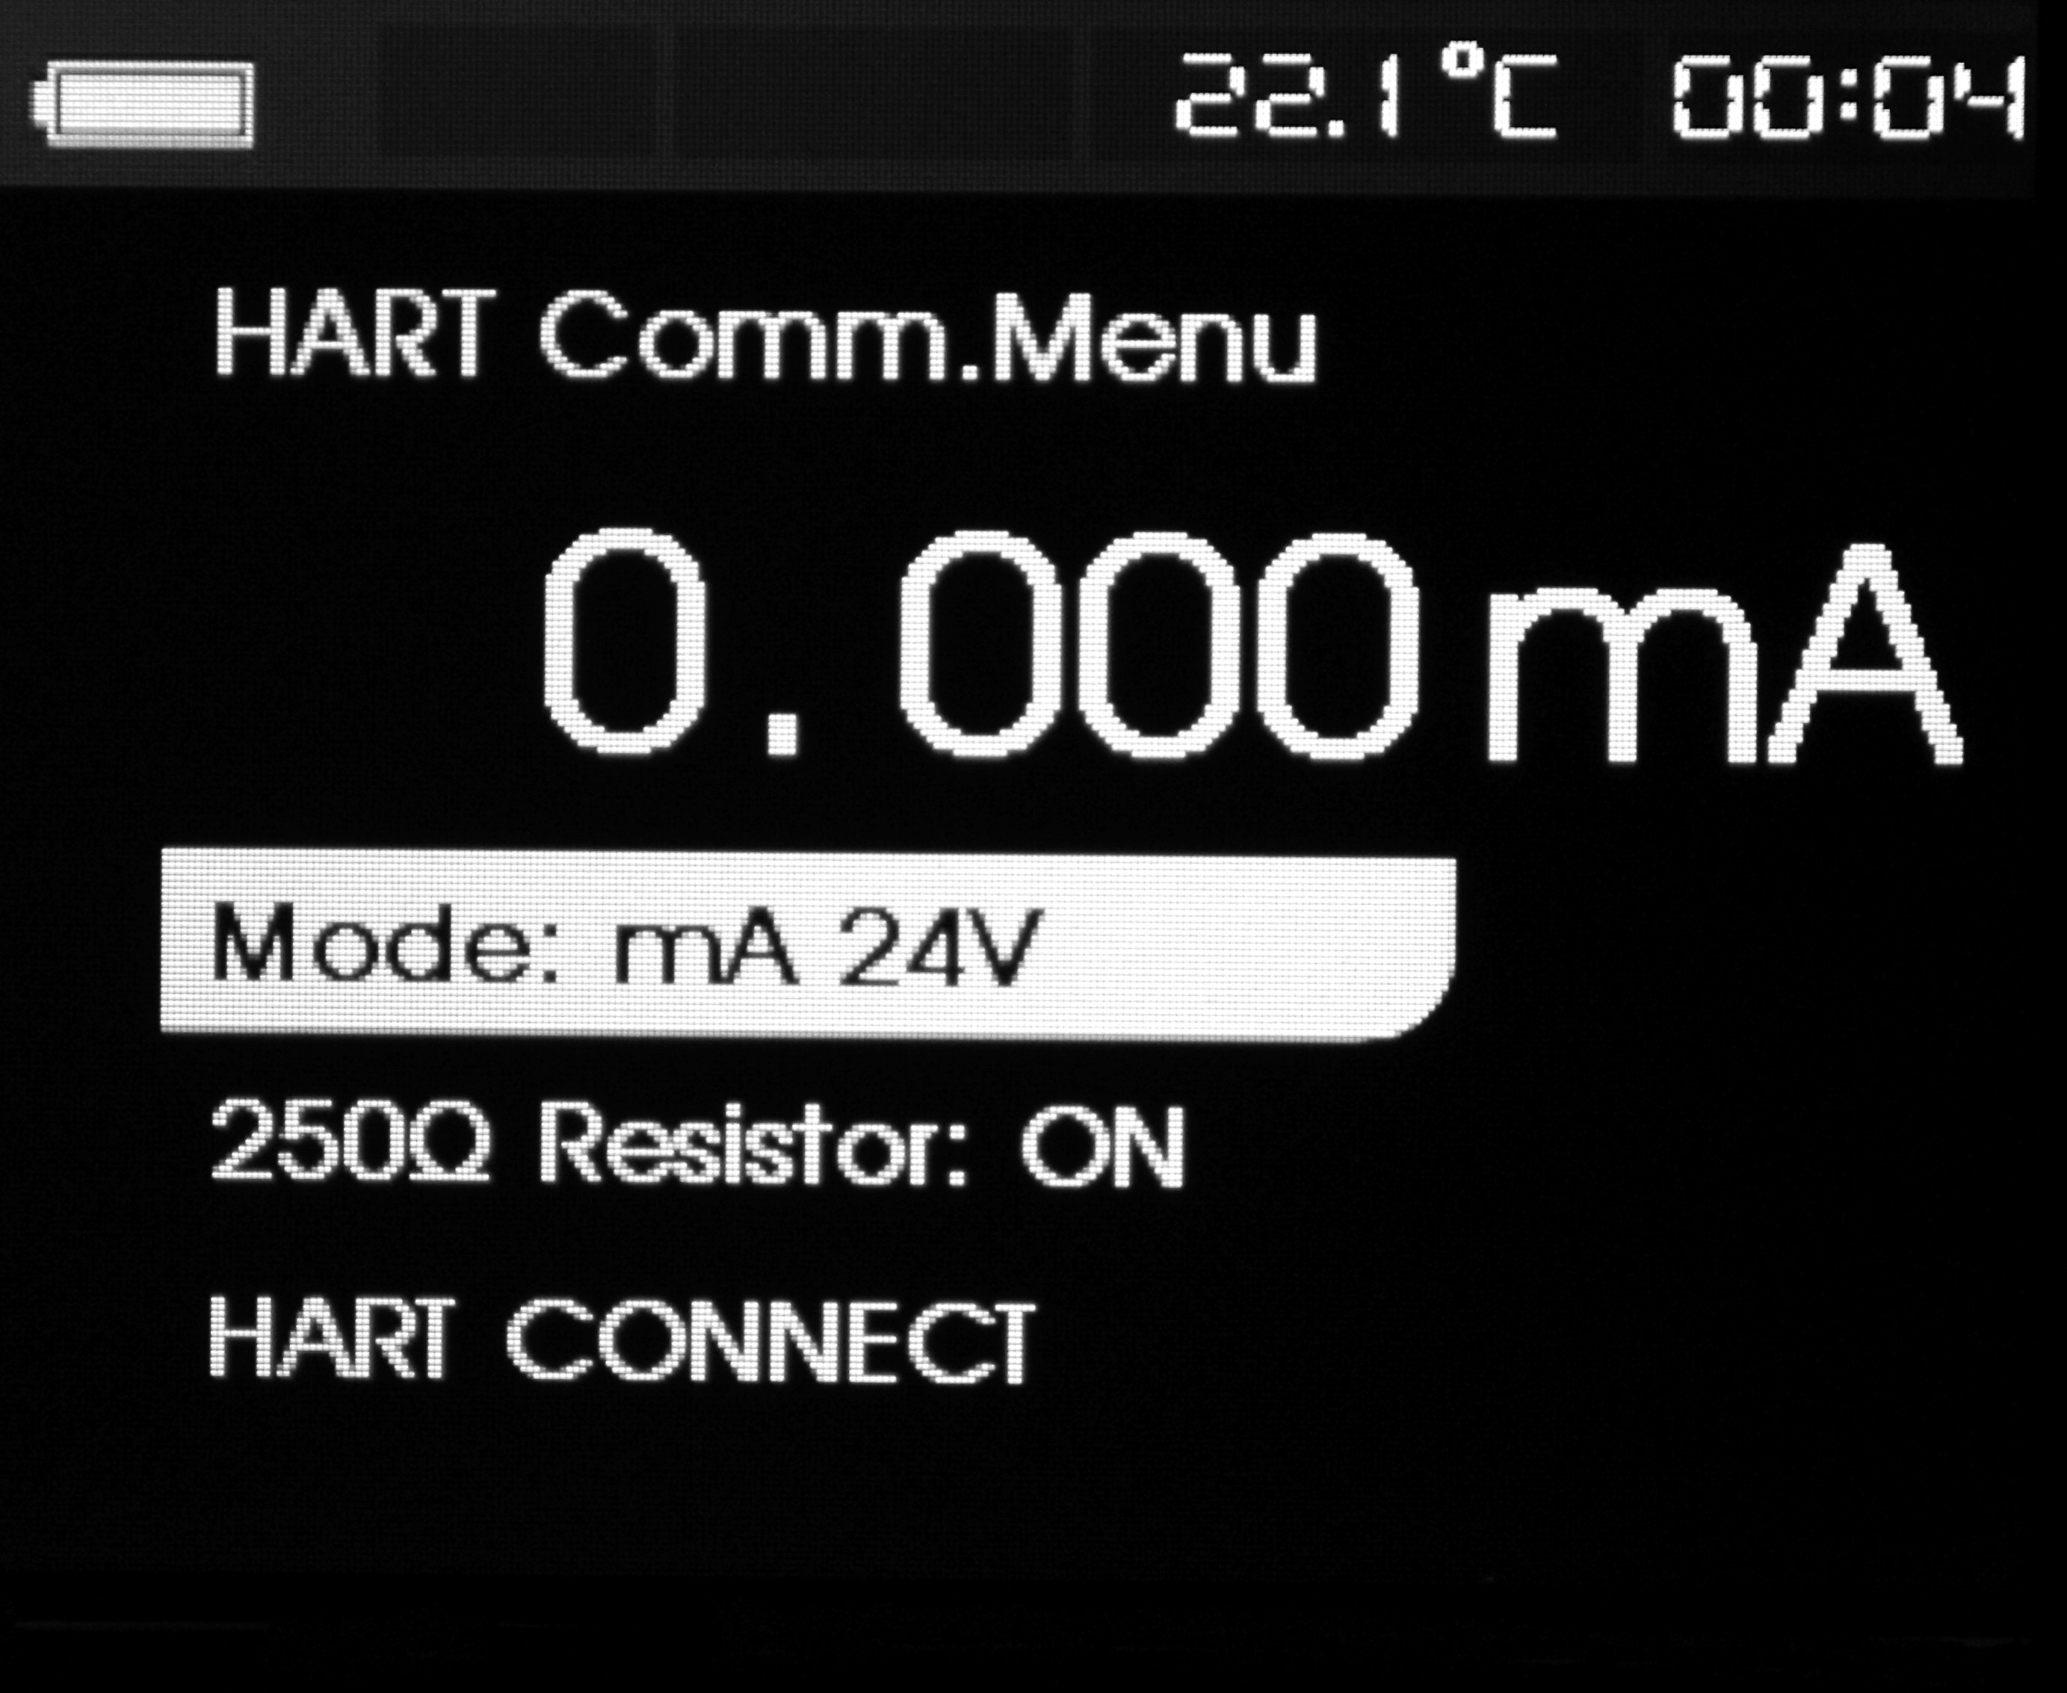
Press switch rotary key and select a function from the menu and then press ENTER key to execute this function. If the measured input signal exceeds the range, the screen displays an error OL or –OL, and does not undertake any operation.
    - Mode
Mode function in HART communication menu is used to select working state.
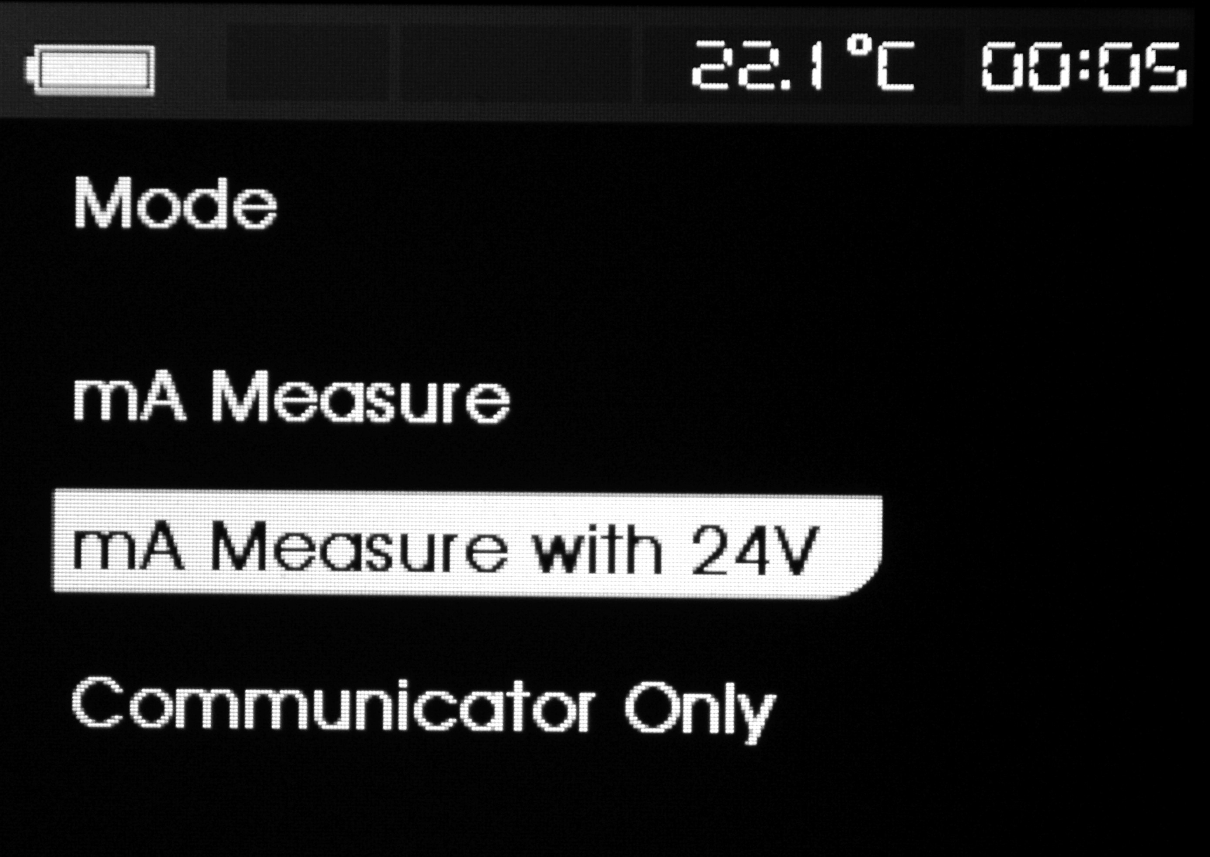
    - 250Ω HART resistance
Resistance function is used to start or close 250ΩHART resistance.

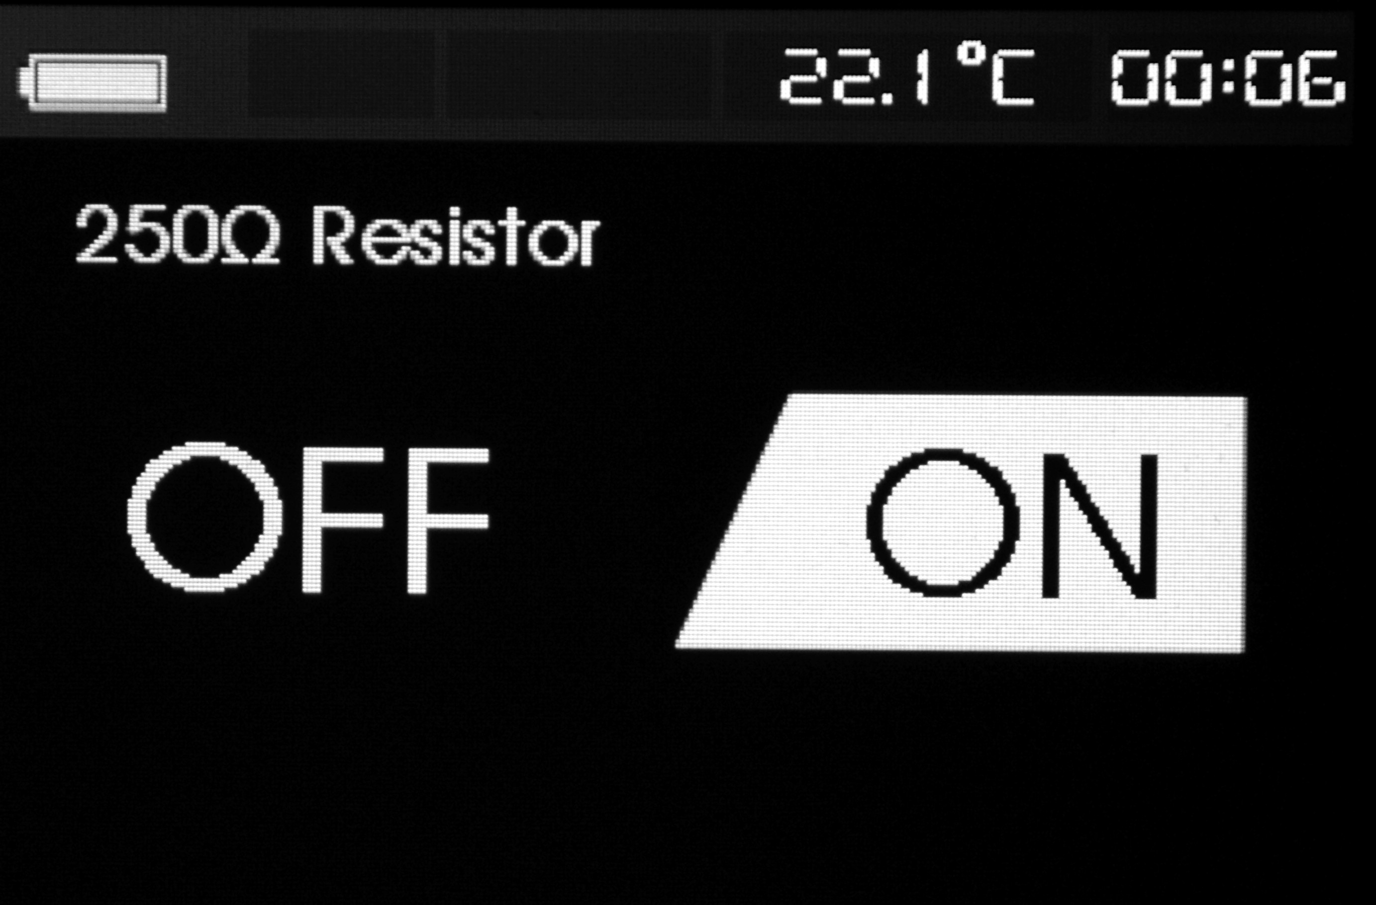
    - HART connection
HART connection function is used to locate the HART device in a loop circuit; the device must be installed in the loop circuit before using it, and its implementation model goes like this: firstly polling all possible device address and then select one device from the response addressed. If the calibrator detects more than one device, it will list a tag, and select right device from the list; if the calibrator detects only one device, it will select the device acquiescently. The calibrator will read all relevant data from the detected device.
- Polling loop
Polling loop function is used to search whether there is a HART device in the loop circuit. This function will start immediately after execution of HART connection. With the processing of operation, the screen refreshes every second to display the extension of process bar.

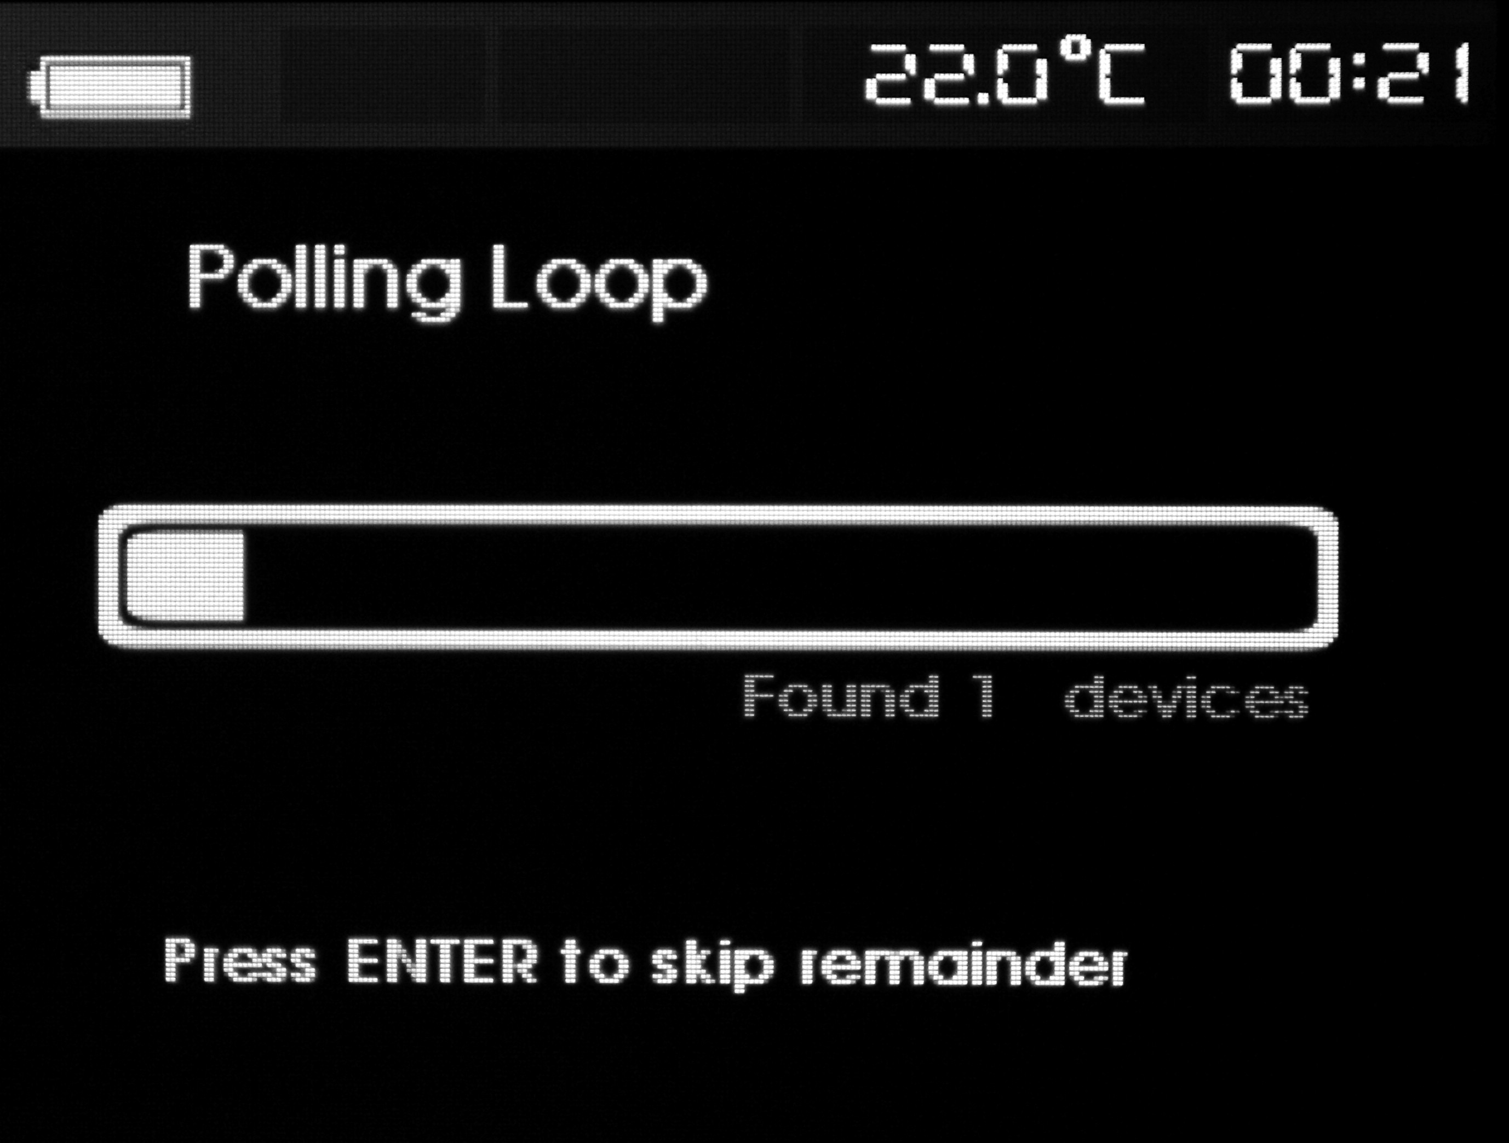
The screen displays the device number detected in loop circuit during the polling process. If the user knows all the devices have been detected, he can press ENTER key to stop polling in advance. Press EXIT key to stop polling and exit from HART mode. If no device is detected, then the calibrator will give a hint. If the calibrator detects more than one device, then it will list a tag, and select right device from the list. If the calibrator detects only one device, it will jump over the tag selection step.
- Tag selection
The tag selection screen lists all names of long tags detected in the polling. The name may be displayed in two lines if necessary to show all text. If long tag is not available or is blank, then short tag is used. If the short tag name is blank, then the polling address x<empty> is used. Switch the rotary key to select necessary tag.
- Data collection
When the calibrator gets all the configured data in the installed device, the data collection screen will be in display. The process bar extends every second to show the process. Symbol blinks in the upper right corner to show real-time HART connection.

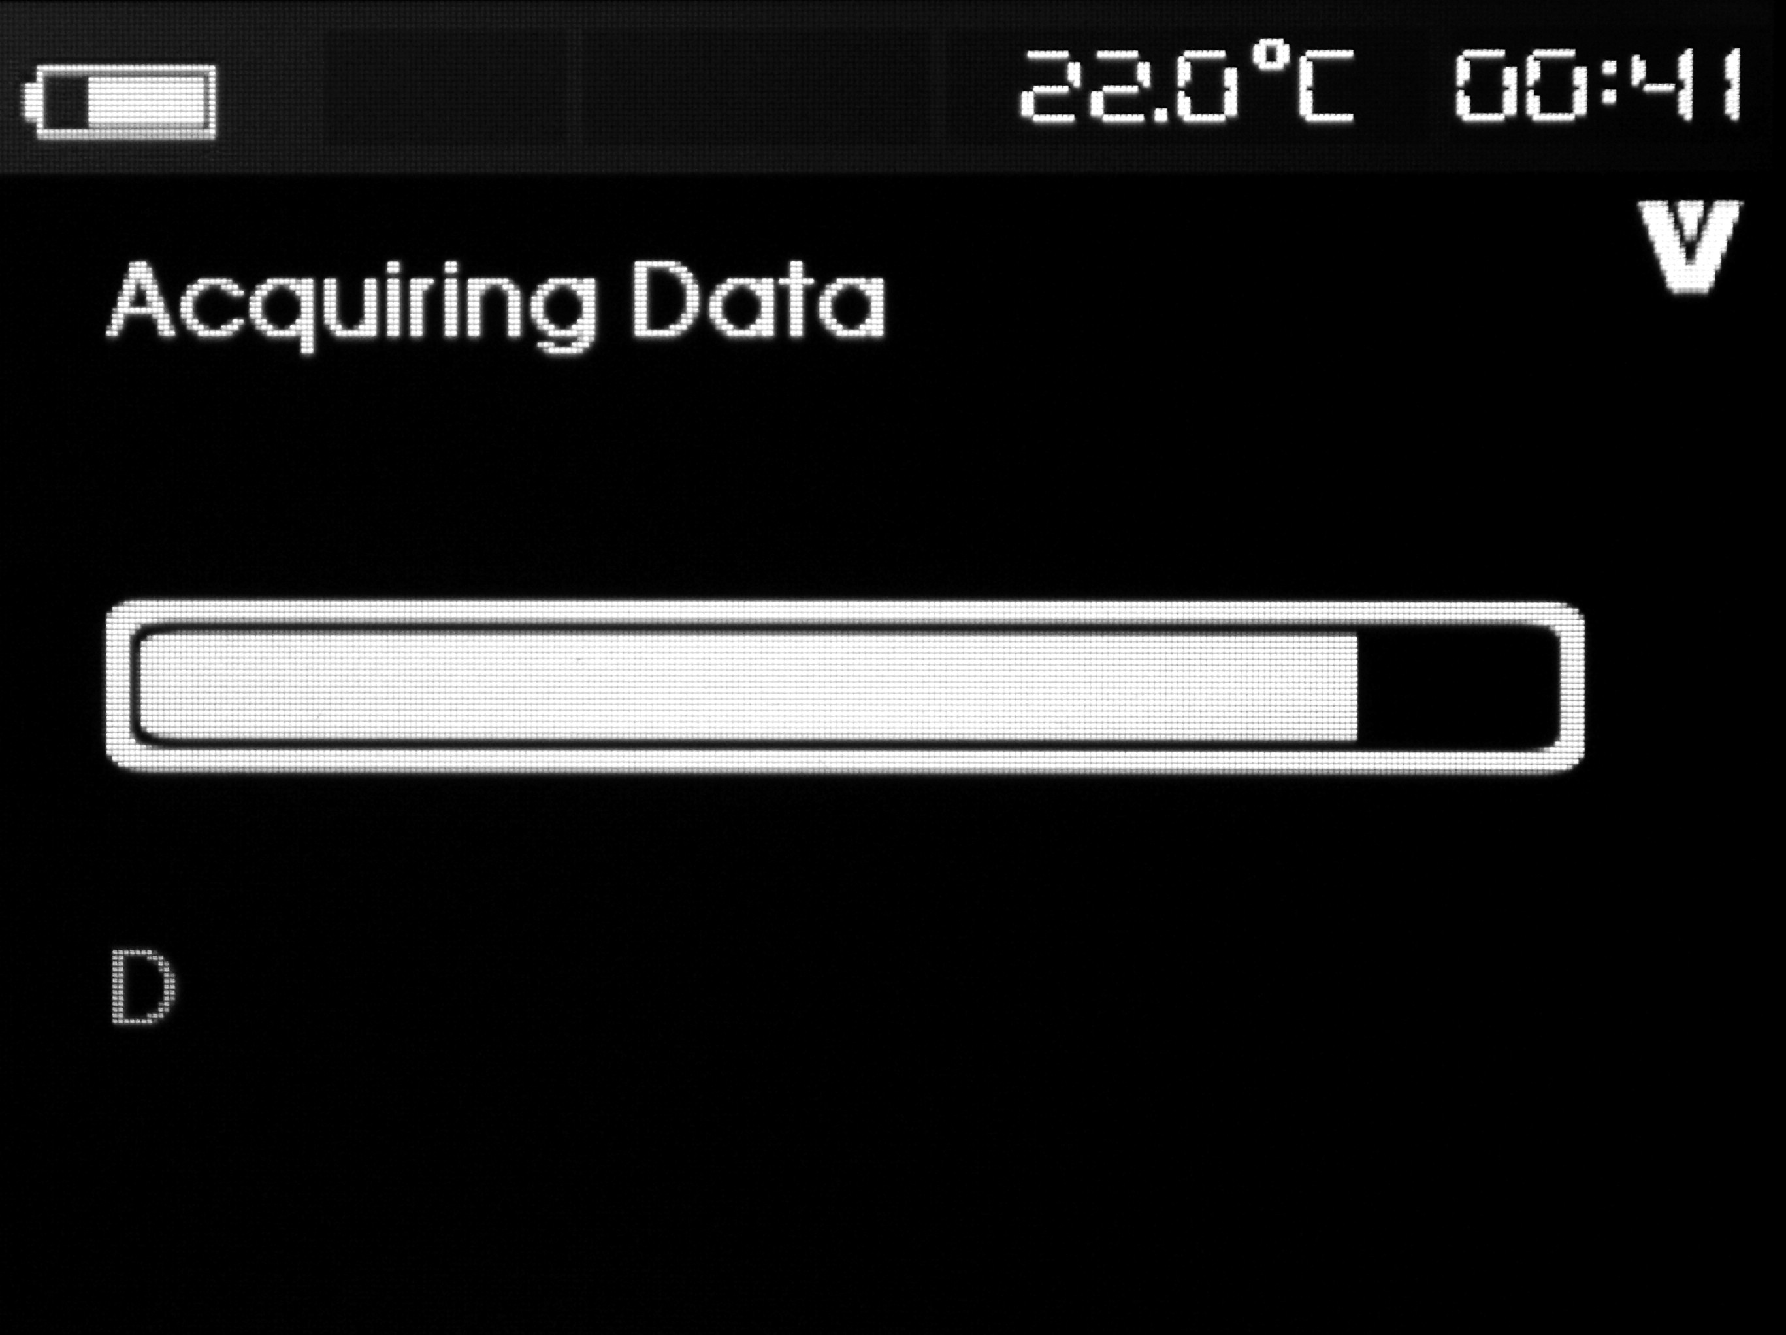
The screen displays all tag names visited. Press EXIT key to stop data collection and exit from HART mode.
- Function selection
After the calibrator finishes the data collection, the screen shows functional selection menu. The menu includes five items.
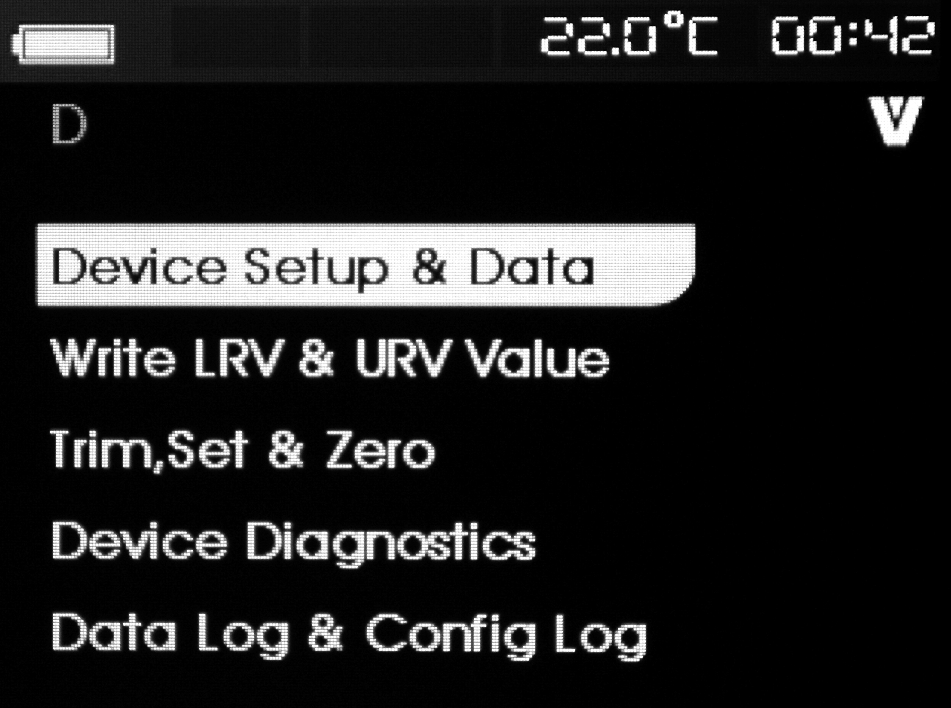
Symbol blinks in the upper right conner to show real-time HART connection. Switch the rotary key to select necessary operation and press ENTER key to execute the selected operation.Press EXIT key to exit from HART mode.
- Device setting and data
The first option in the function menu displays device setting and data function; the device setting and data screen includes eleven sub-screens, switch rotary key to check every sub-screen, and the format of the sub-screen is shown as follows:

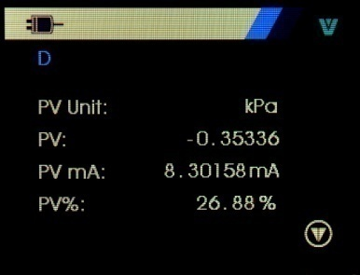
The screen displays all data collected during the collection process. Symbol blinks in the upper right corner, and show real-time HART connection.
Every screen includes six data maximally. If the data is not supported by the HART device, then the mark n/a (not available) displays. The dynamically changed data in the HART device will refreshes in a possible highly frequency in the screen
Switch rotary key to shift between screens. Press EXIT key to exit.
- Write-in LRV and URV data
The second item in the function selection menu is write-in LRV and URV data function. Symbol blinks in the upper right conner to show real-time HART connection.

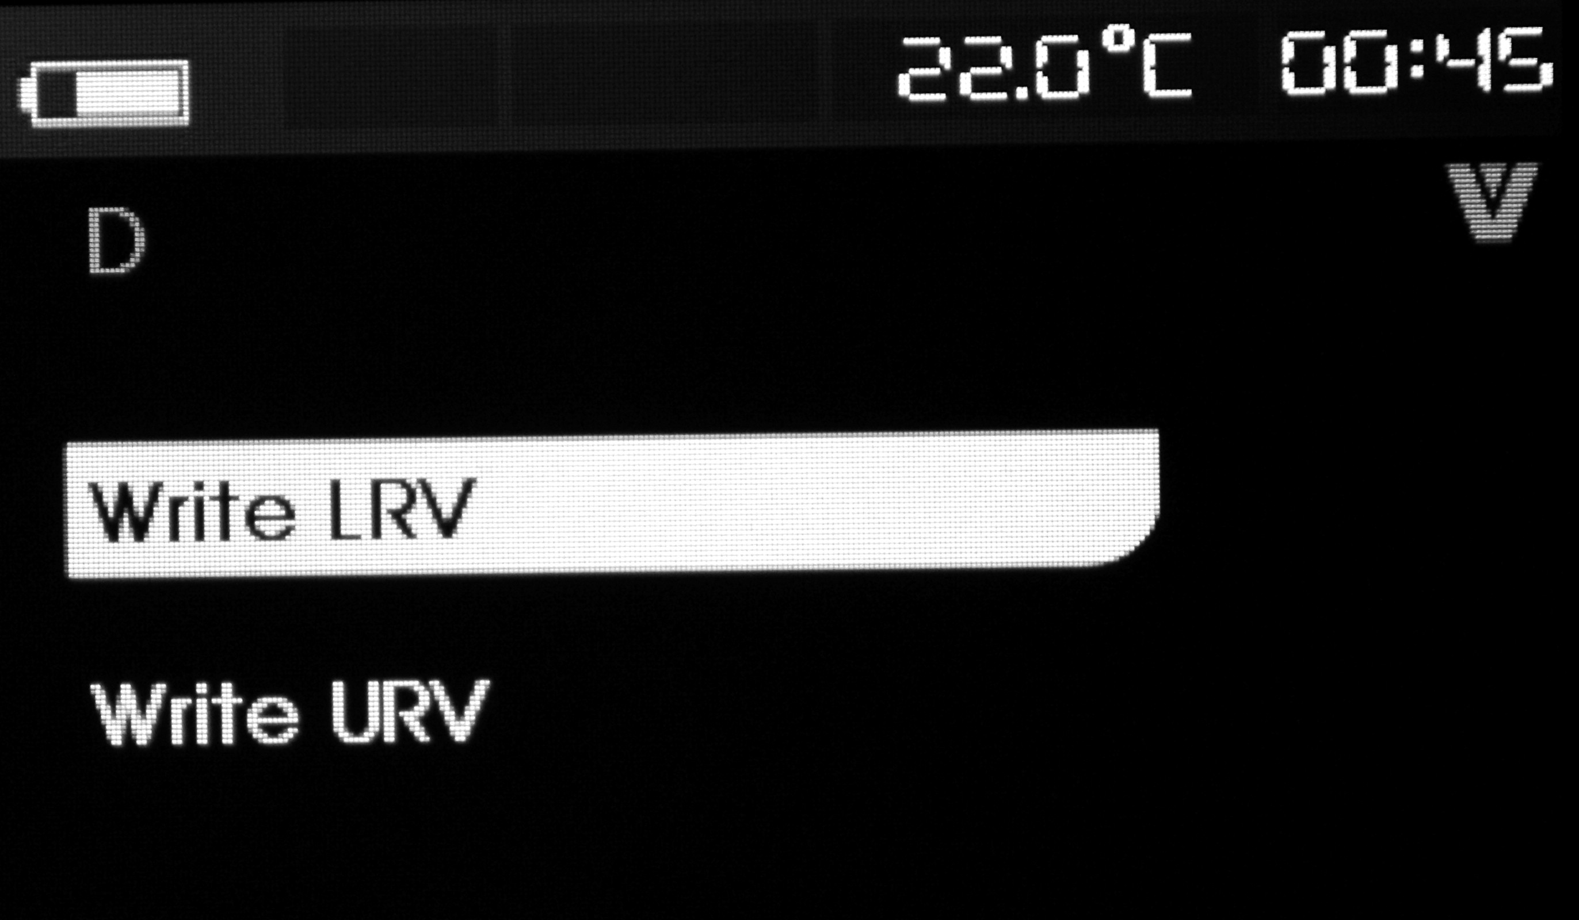
If the HART write-in instruction is not started, this function is not available and the calibrator will give an unopened hint. Switch the rotary key to select necessary operation and press ENTER key to execute the selected operation. Press EXIT key to exit.
Write-in LRV
Before continuing your operation, this calibrator will remind you that the loop circuit will be changed to manual operation. Press ENTER key to continue operation. The screen shows the present LRV data and unit.
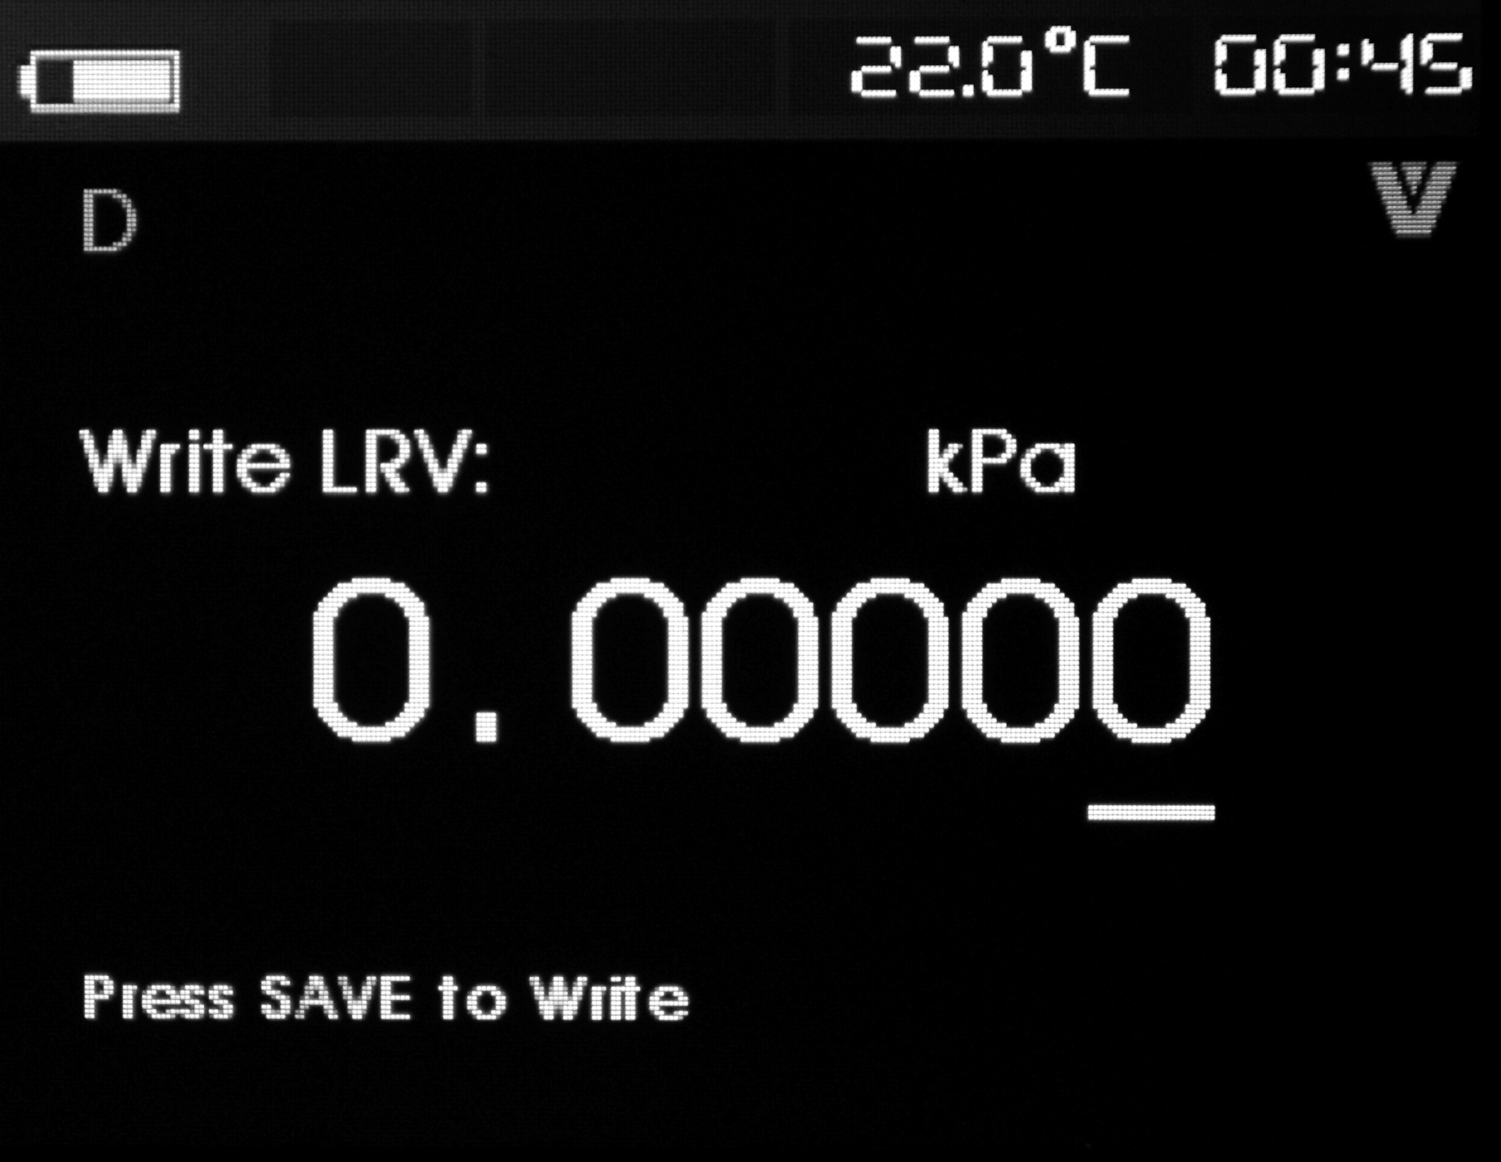
Press EXIT key to exit.
Specified operation to change LRV data:
Step 1：Switch rotary key to adjust LRV data to necessary paracalibrator.
Step 2：Press [SAVE] key to send new data to HART device. If HART device refuses this data, then the screen shows an error.
Step 3：The screen will give a hint that the loop circuit will go back to auto mode after successful sending of the data.
Step 4：Press the EXIT key to exit.
Write-in URV
Before continuing your operation, this calibrator will remind you that the loop circuit will be changed to manual operation. Press ENTER key to continue operation and the screen shows the present URV data and unit.

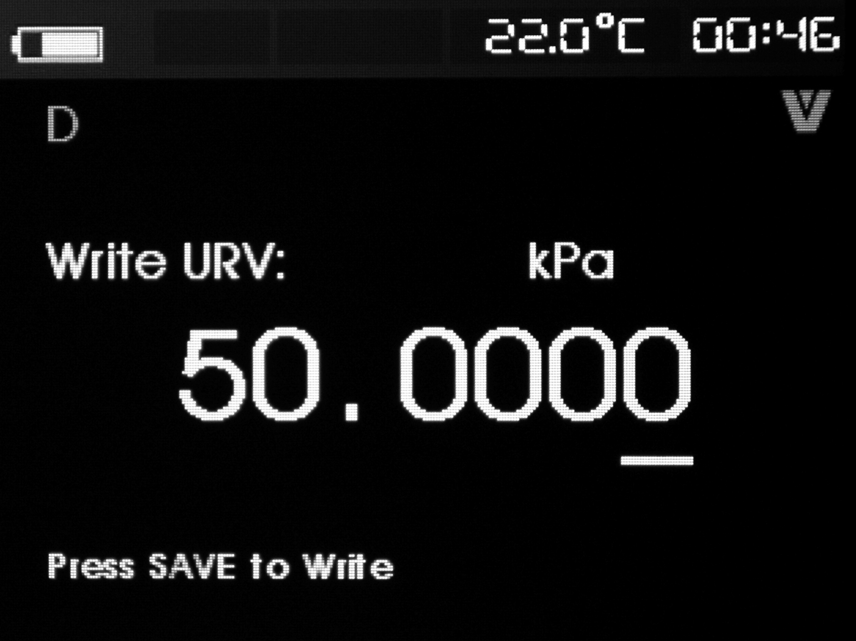
Press EXIT key to exit.
Specified operation to change URV data:
Step 1：Switch rotary key to adjust URV data to necessary parameter.
Step 2：Press [SAVE] key to send new data to HART device. If HART device refuses this data, then the screen shows an error.
Step 3：The screen will give a hint that the loop circuit will go back to auto mode after successful sending of the data.
Step 4：Press the EXIT key to exit.
- Micro-adjustment, setting and zero menu
The third item in the function selection menu is micro-adjustment, setting and zero menu; Symbol blinks in the upper right conner to show real-time HART connection.

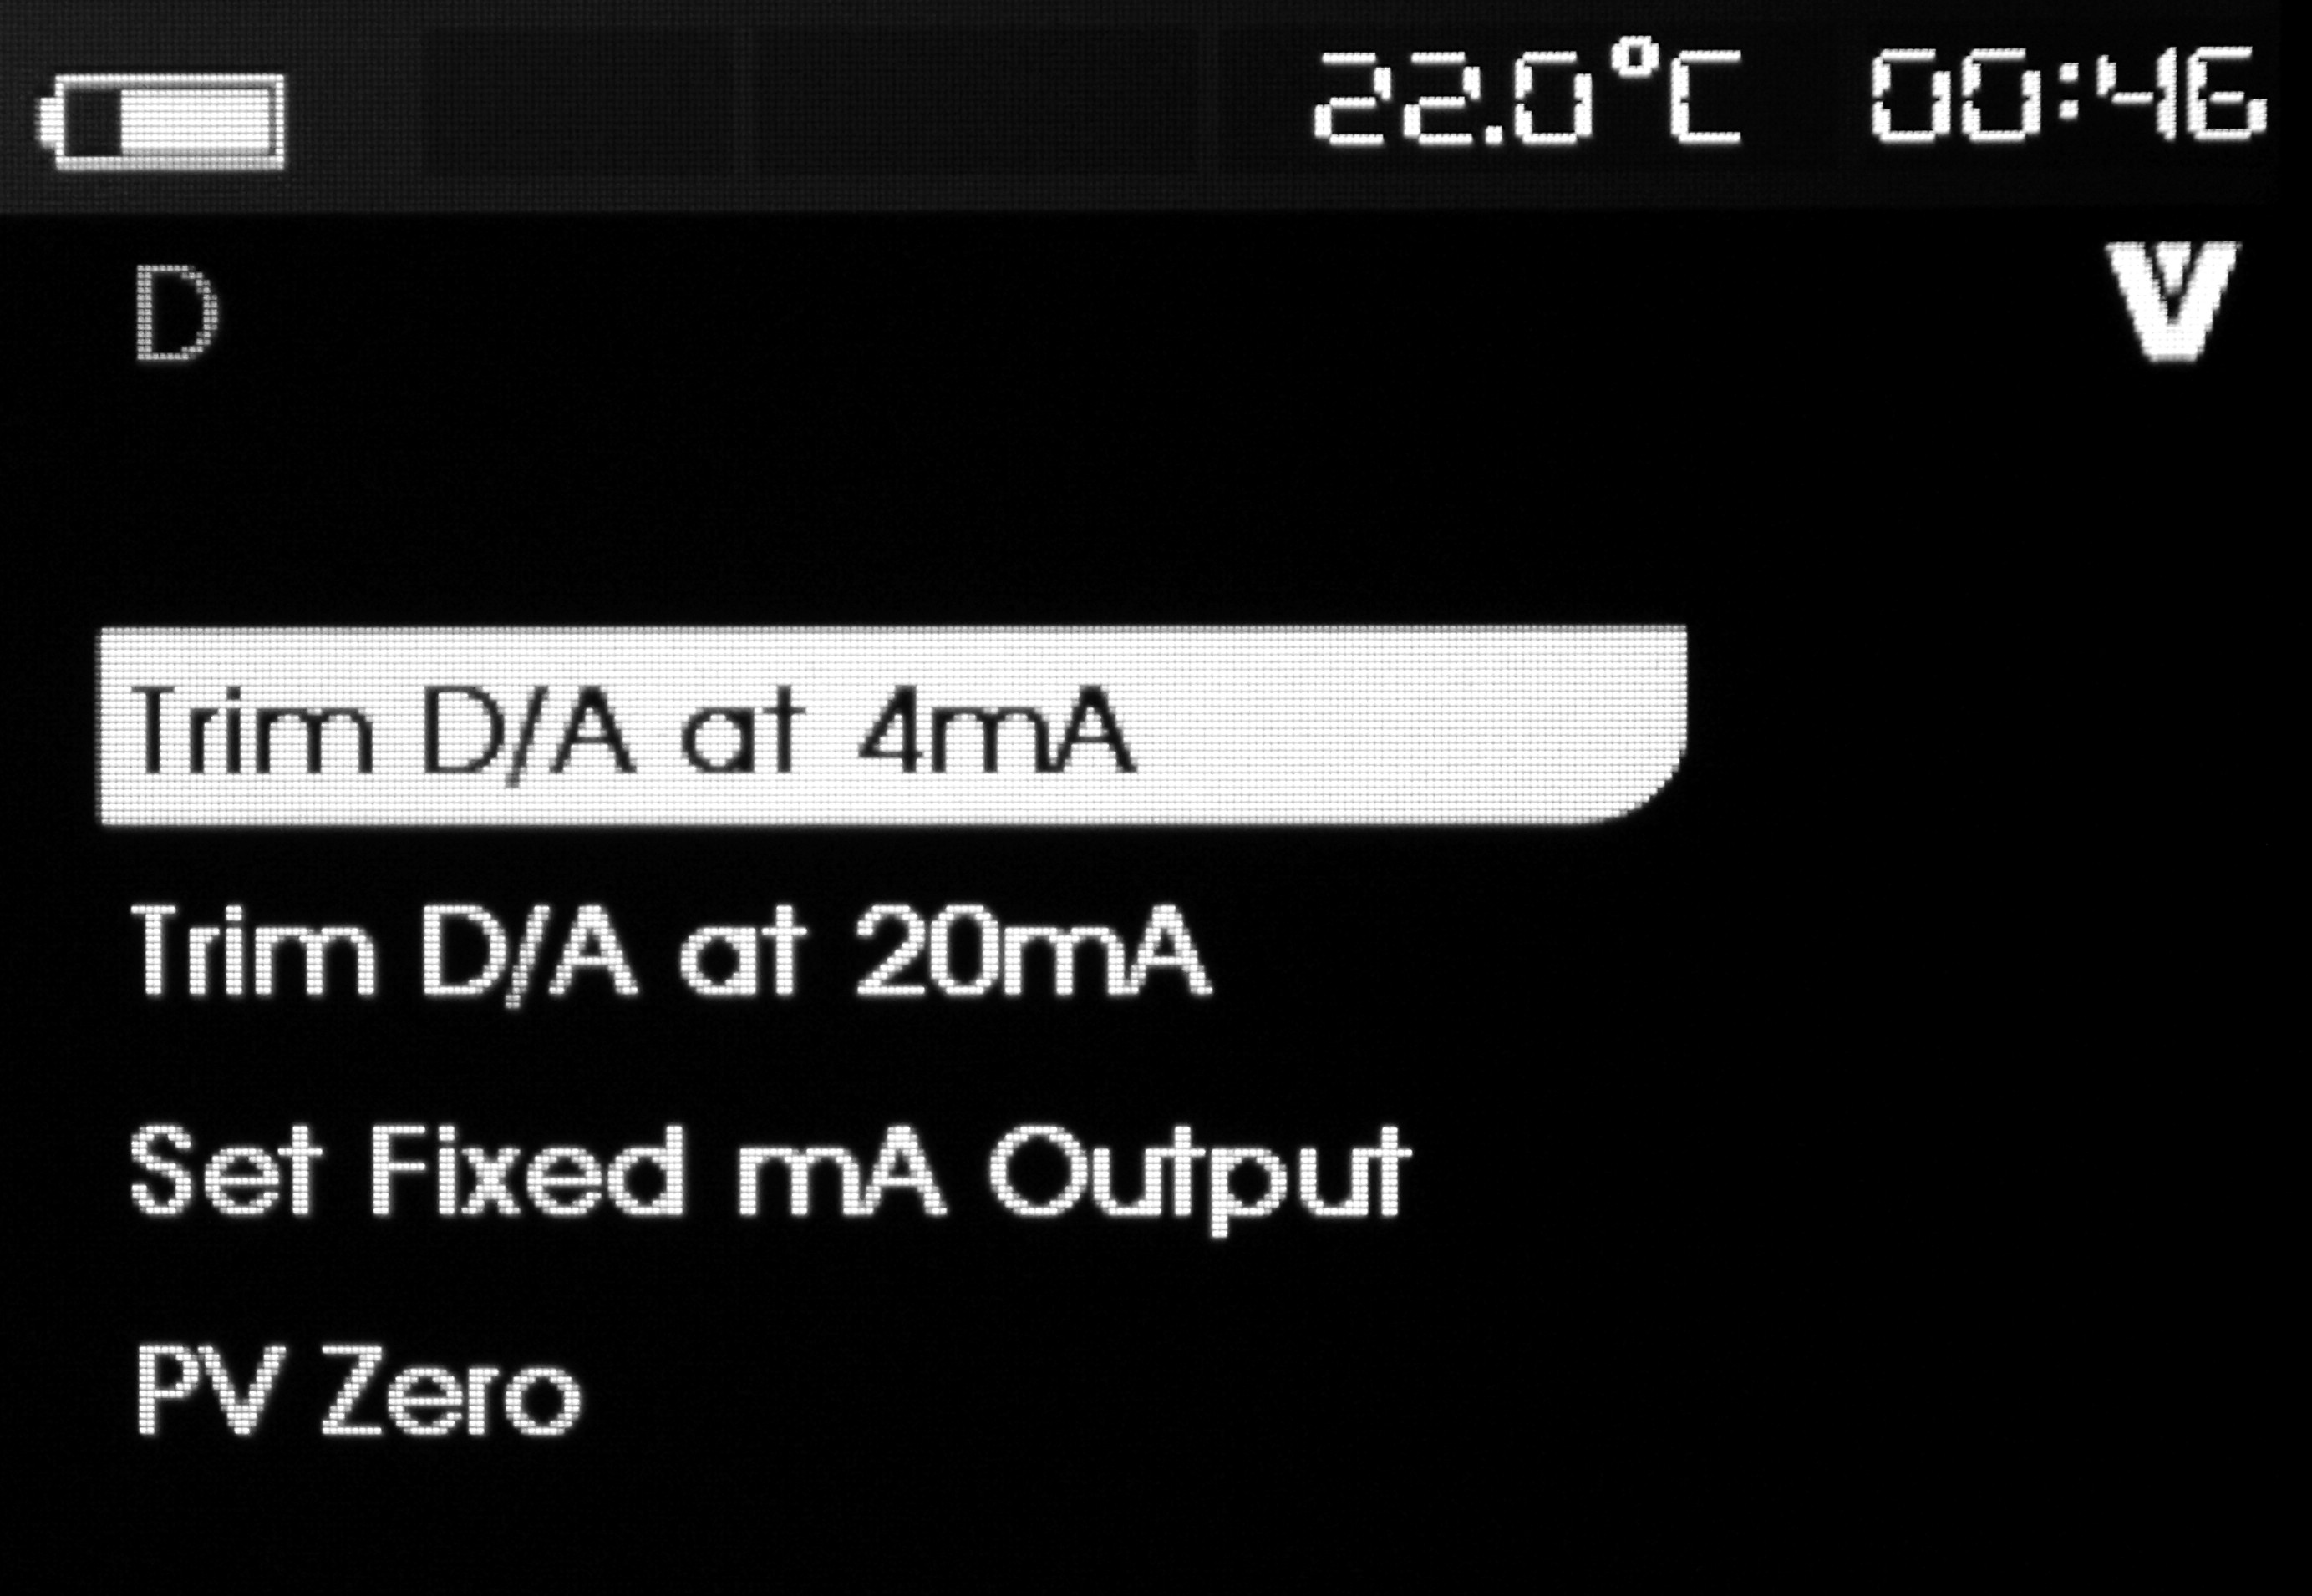
If the HART write-in instruction is not started, this function is not available and the calibrator will give an unopened hint. This function is prohibited in communication mode. Switch the rotary key to select necessary operation and press ENTER key to execute the selected operation. Press EXIT key to exit.
4mA Micro-adjustment
If the operation mode is restricted in communication, this function is not available and the calibrator will give an error hint. Before continuing your operation, the calibrator will remind you of changing your circuit back to manual mode. Press the ENTER key to continue. When the HART device is changed to fixed output mode, the screen will display an error if the HART device refuses the mode changing command. When the mode is successfully changed, then the screen will display as shown in the following figure:

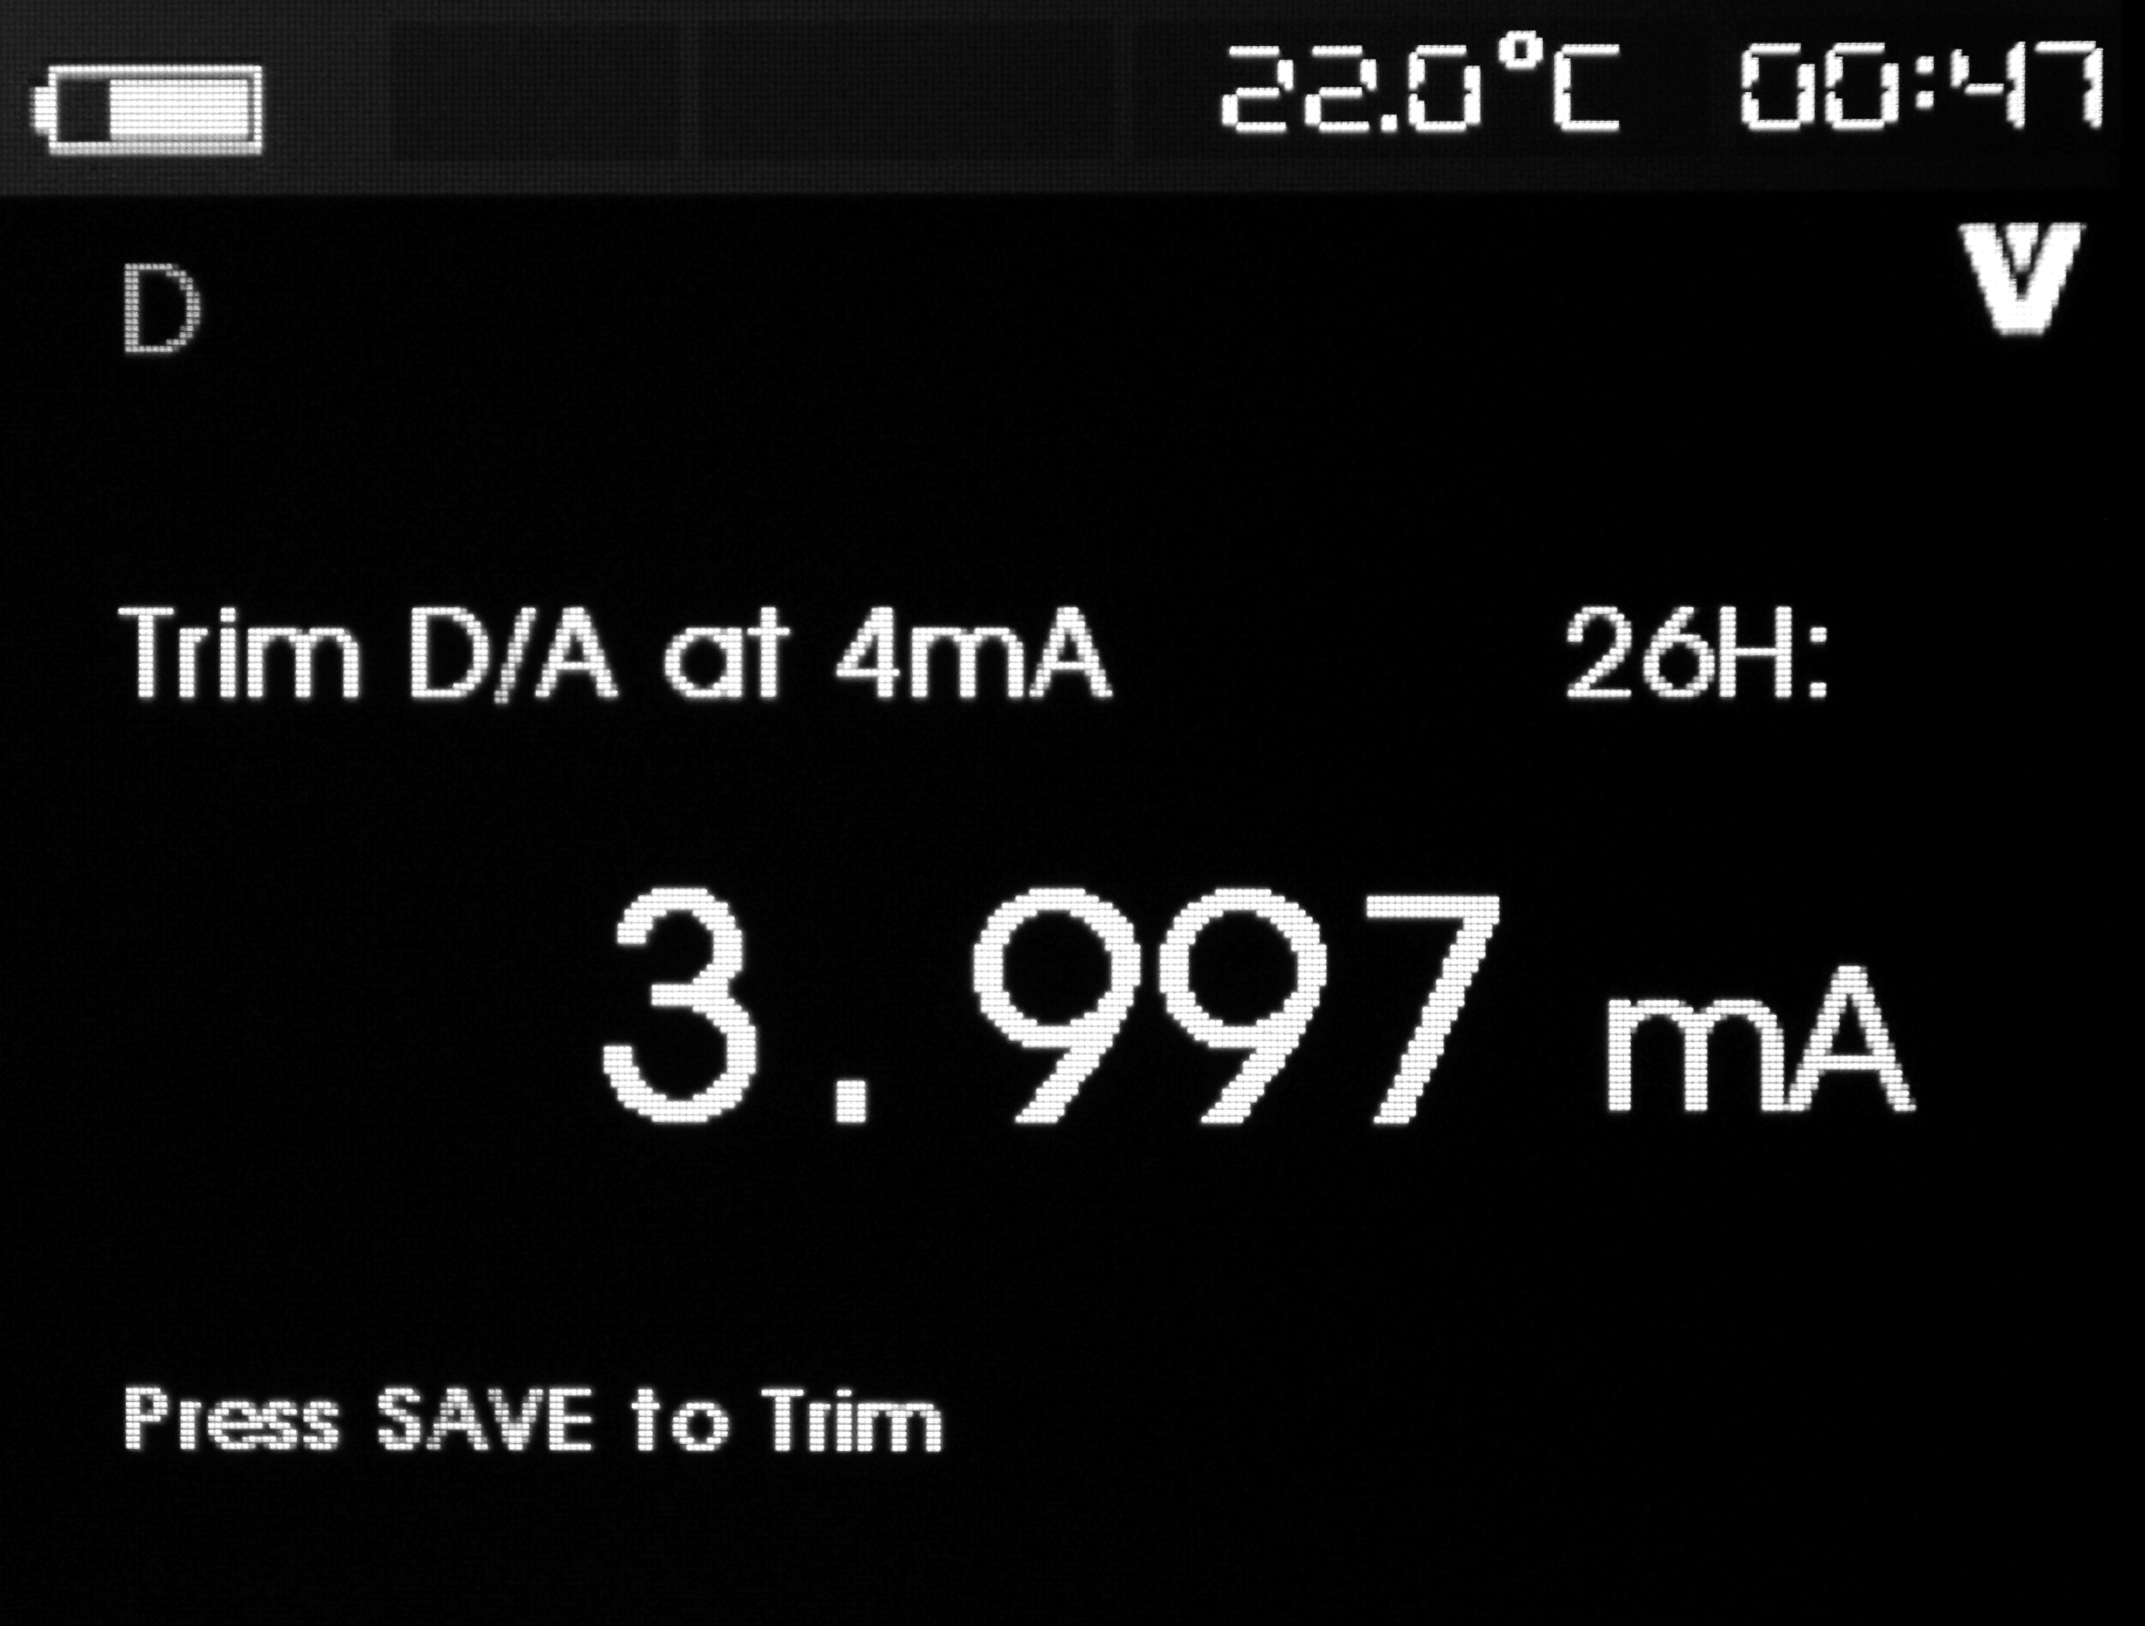
When the output value is fixed at 4mA, the screen will display the measured value of the calibrator. And the measured value will refresh every second. Specified operation for 4mA micro-adjustment:
Step 1: Press ENTER to micro adjust HART device. And then evaluate the result in the mode. If the device refuses the mode changing demand, the screen will display an error.
Step 2: Press EXIT key, the screen will give a hint to change to normal output mode, and then give a hint to change to auto mode. If the device refuses the mode changing demand, the screen will display an error.
20mA Micro-adjustment
If the operation mode is restricted in communication, this function is not available and the calibrator will give an error hint. Before continuing your operation, the calibrator will remind you of changing your circuit back to manual mode. Press the ENTER key to continue. When the HART device is changed to fixed output mode, the screen will display an error if the HART device refuses the mode changing command. When the mode is successfully changed, then the screen will display as shown in the following figure:
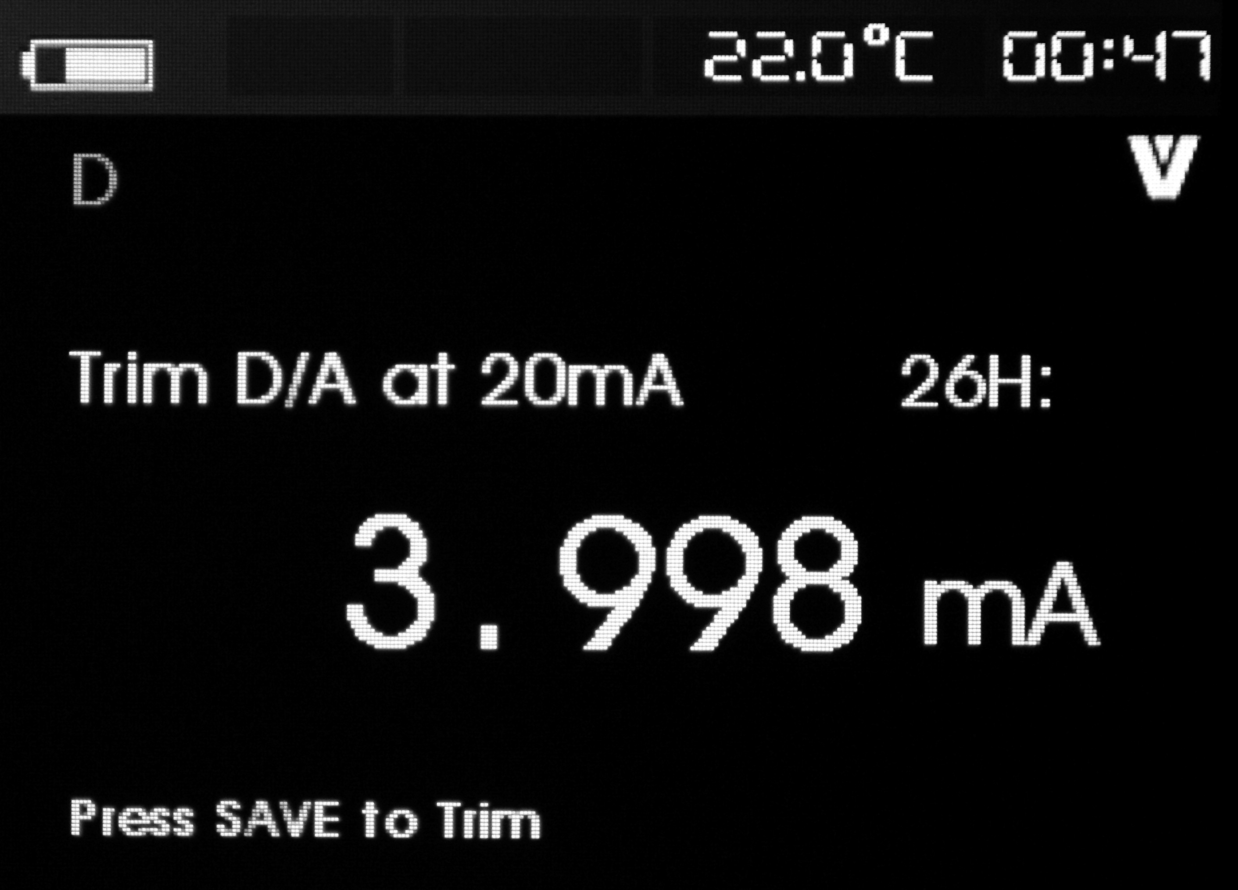
When the output value is fixed at 20mA, the screen will display the measured value of the calibrator. And the measured value will refresh every second. Specified operation for 20mA Micro-adjustment:
Step 1: Press [SAVE] to micro adjust HART device. And then evaluate the result in the mode. If the device refuses the mode changing demand, the screen will display an error.
Step 2: Press EXIT key, the screen will give a hint to change to normal output mode, and then give a hint to change to auto mode. If the device refuses the mode changing demand, the screen will display an error.
Set fixed mA output
If the operation mode is restricted in communication, this function is not available and the calibrator will give an error hint. Before continuing your operation, the calibrator will remind you of changing your circuit back to manual mode. Press the ENTER key to continue. The HART device is changed to fixed output mode, the screen will display an error if the HART device refuses the mode changing command. When the mode is successfully changed, then the screen will display as shown in the following figure:
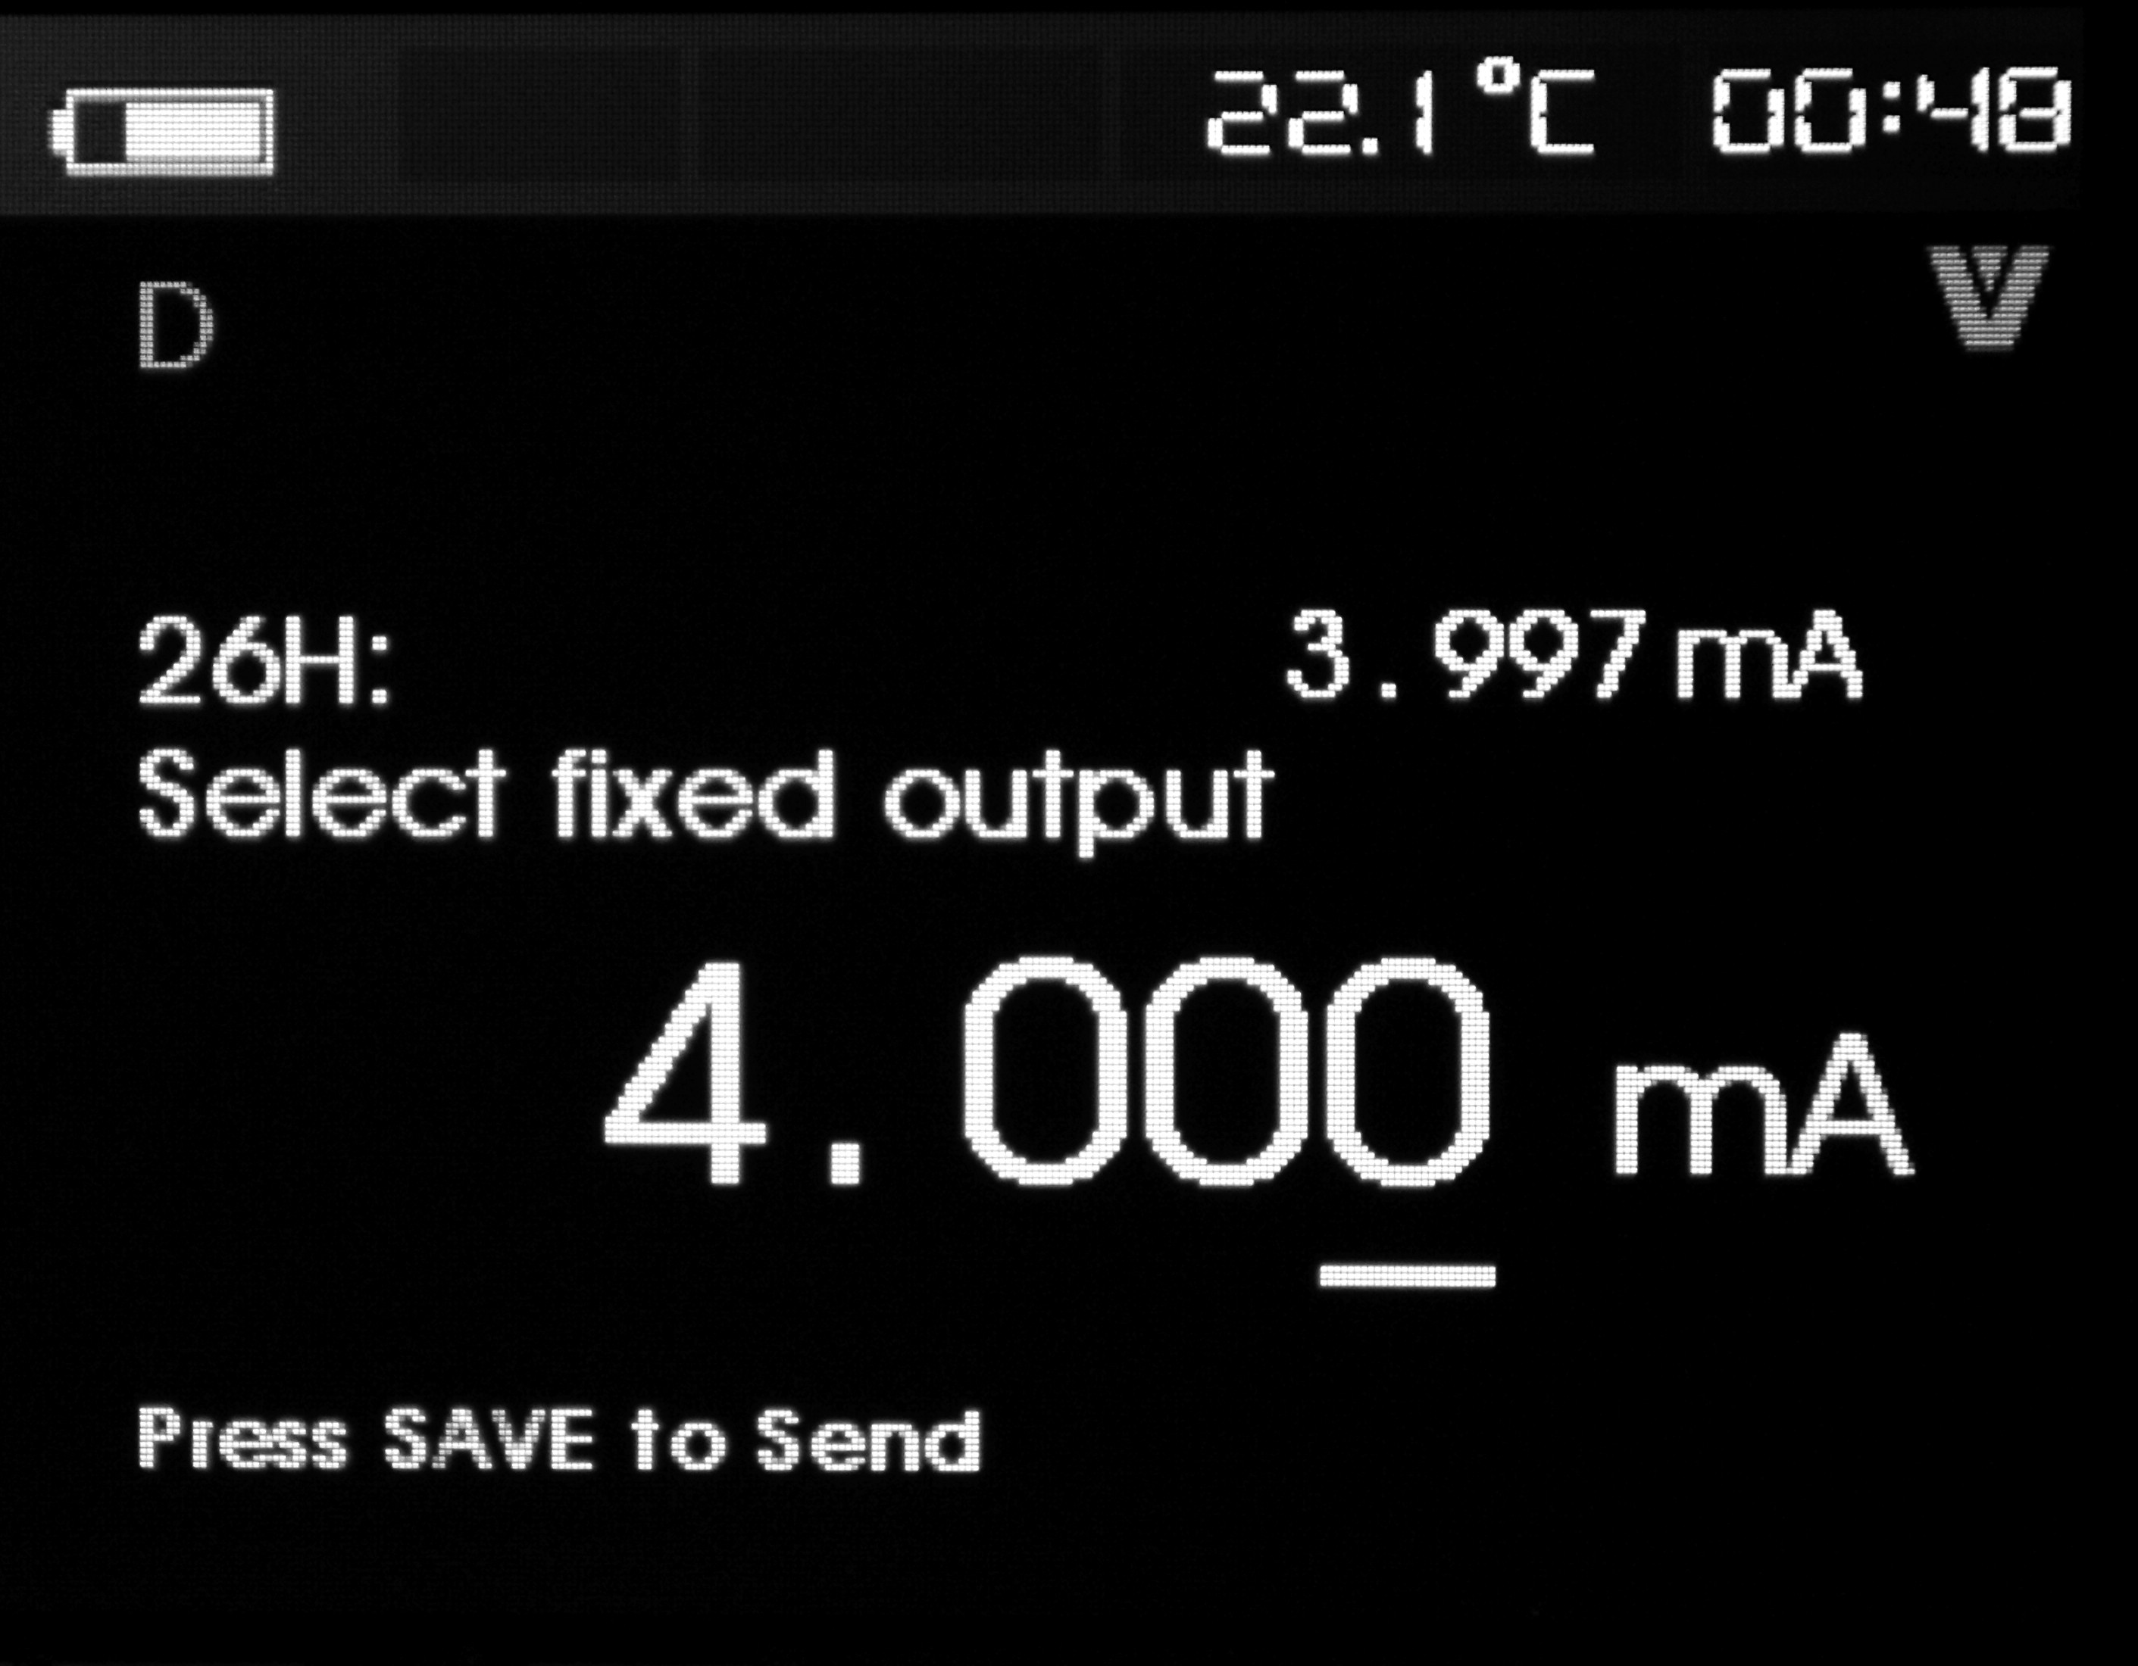
This mode is used to set fixed output, and monitor the result by the measured value of the calibrator. And the measured value will refresh every second. The setting range of the value is 3.0 mA ～ 21.0mA. Specified operation for fixed mA output:
Step 1: Switch rotary key, adjust the data to the necessary parameter.
Step 2: Press the [SAVE] key to send the new value to the HART device, and keep in the screen display. The screen will display an error if the HART device refuses the mode changing command.
Step 3: Press EXIT key, the screen will give a hint to change to normal output mode, and then give a hint to change to auto mode. If the device refuses the mode changing demand, the screen will display an error.
PV zero
If the operation mode is restricted in communication, this function is not available and the calibrator will give an error hint. Before continuing your operation, the calibrator will remind you of changing your circuit back to manual mode. Press the ENTER key to continue. And the screen will display as shown in the following figure:

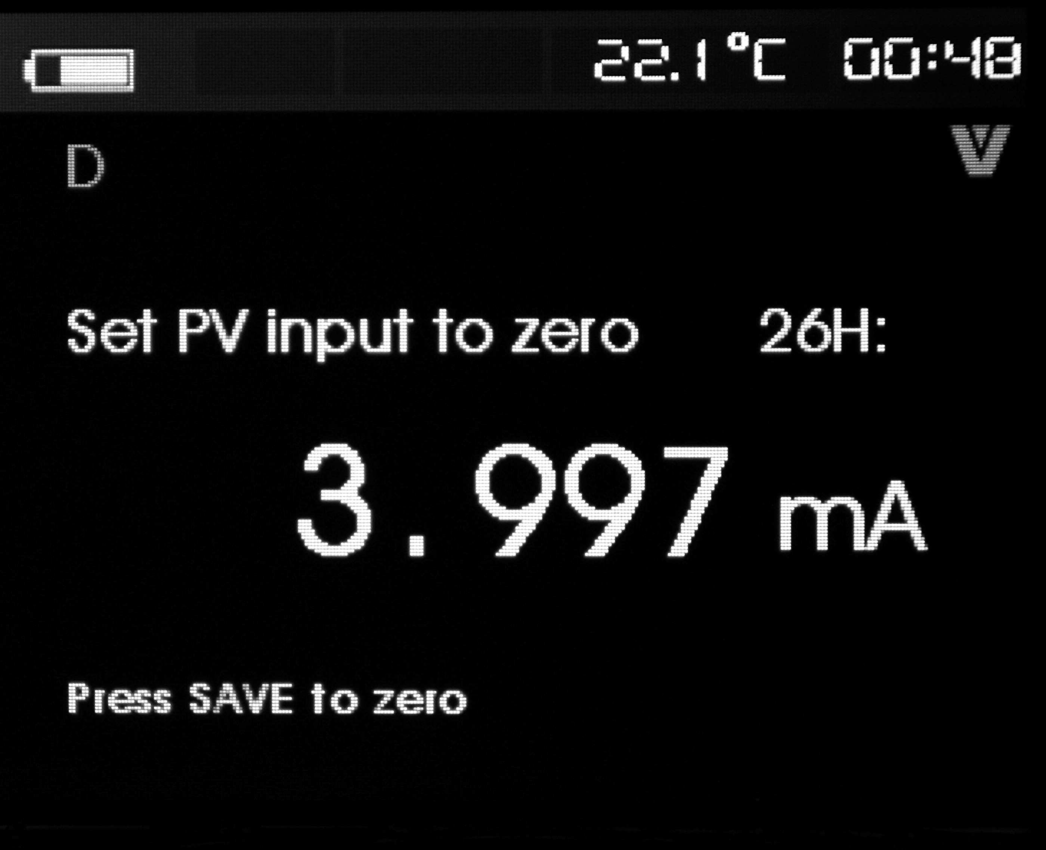
Specified operation for PV zero:
Step 1: Press the grey key to zero the PV input value, and keep in the screen display. The screen will display an error if the HART device refuses the mode changing command.
Step 2: Press EXIT key, the screen will give a hint to save PV input value, and then return back to auto mode.
- Device diagnose
The fourth item in the function selection menu is device diagnose; Symbol blinks in the upper right corner to show real-time HART connection.If the HART write-in instruction is not started, this function is not available and the calibrator will give an unopened hint. Before continuing your operation, the calibrator will remind you of changing your circuit back to manual mode. Press the ENTER key to continue. And the screen will display as shown in the following figure:

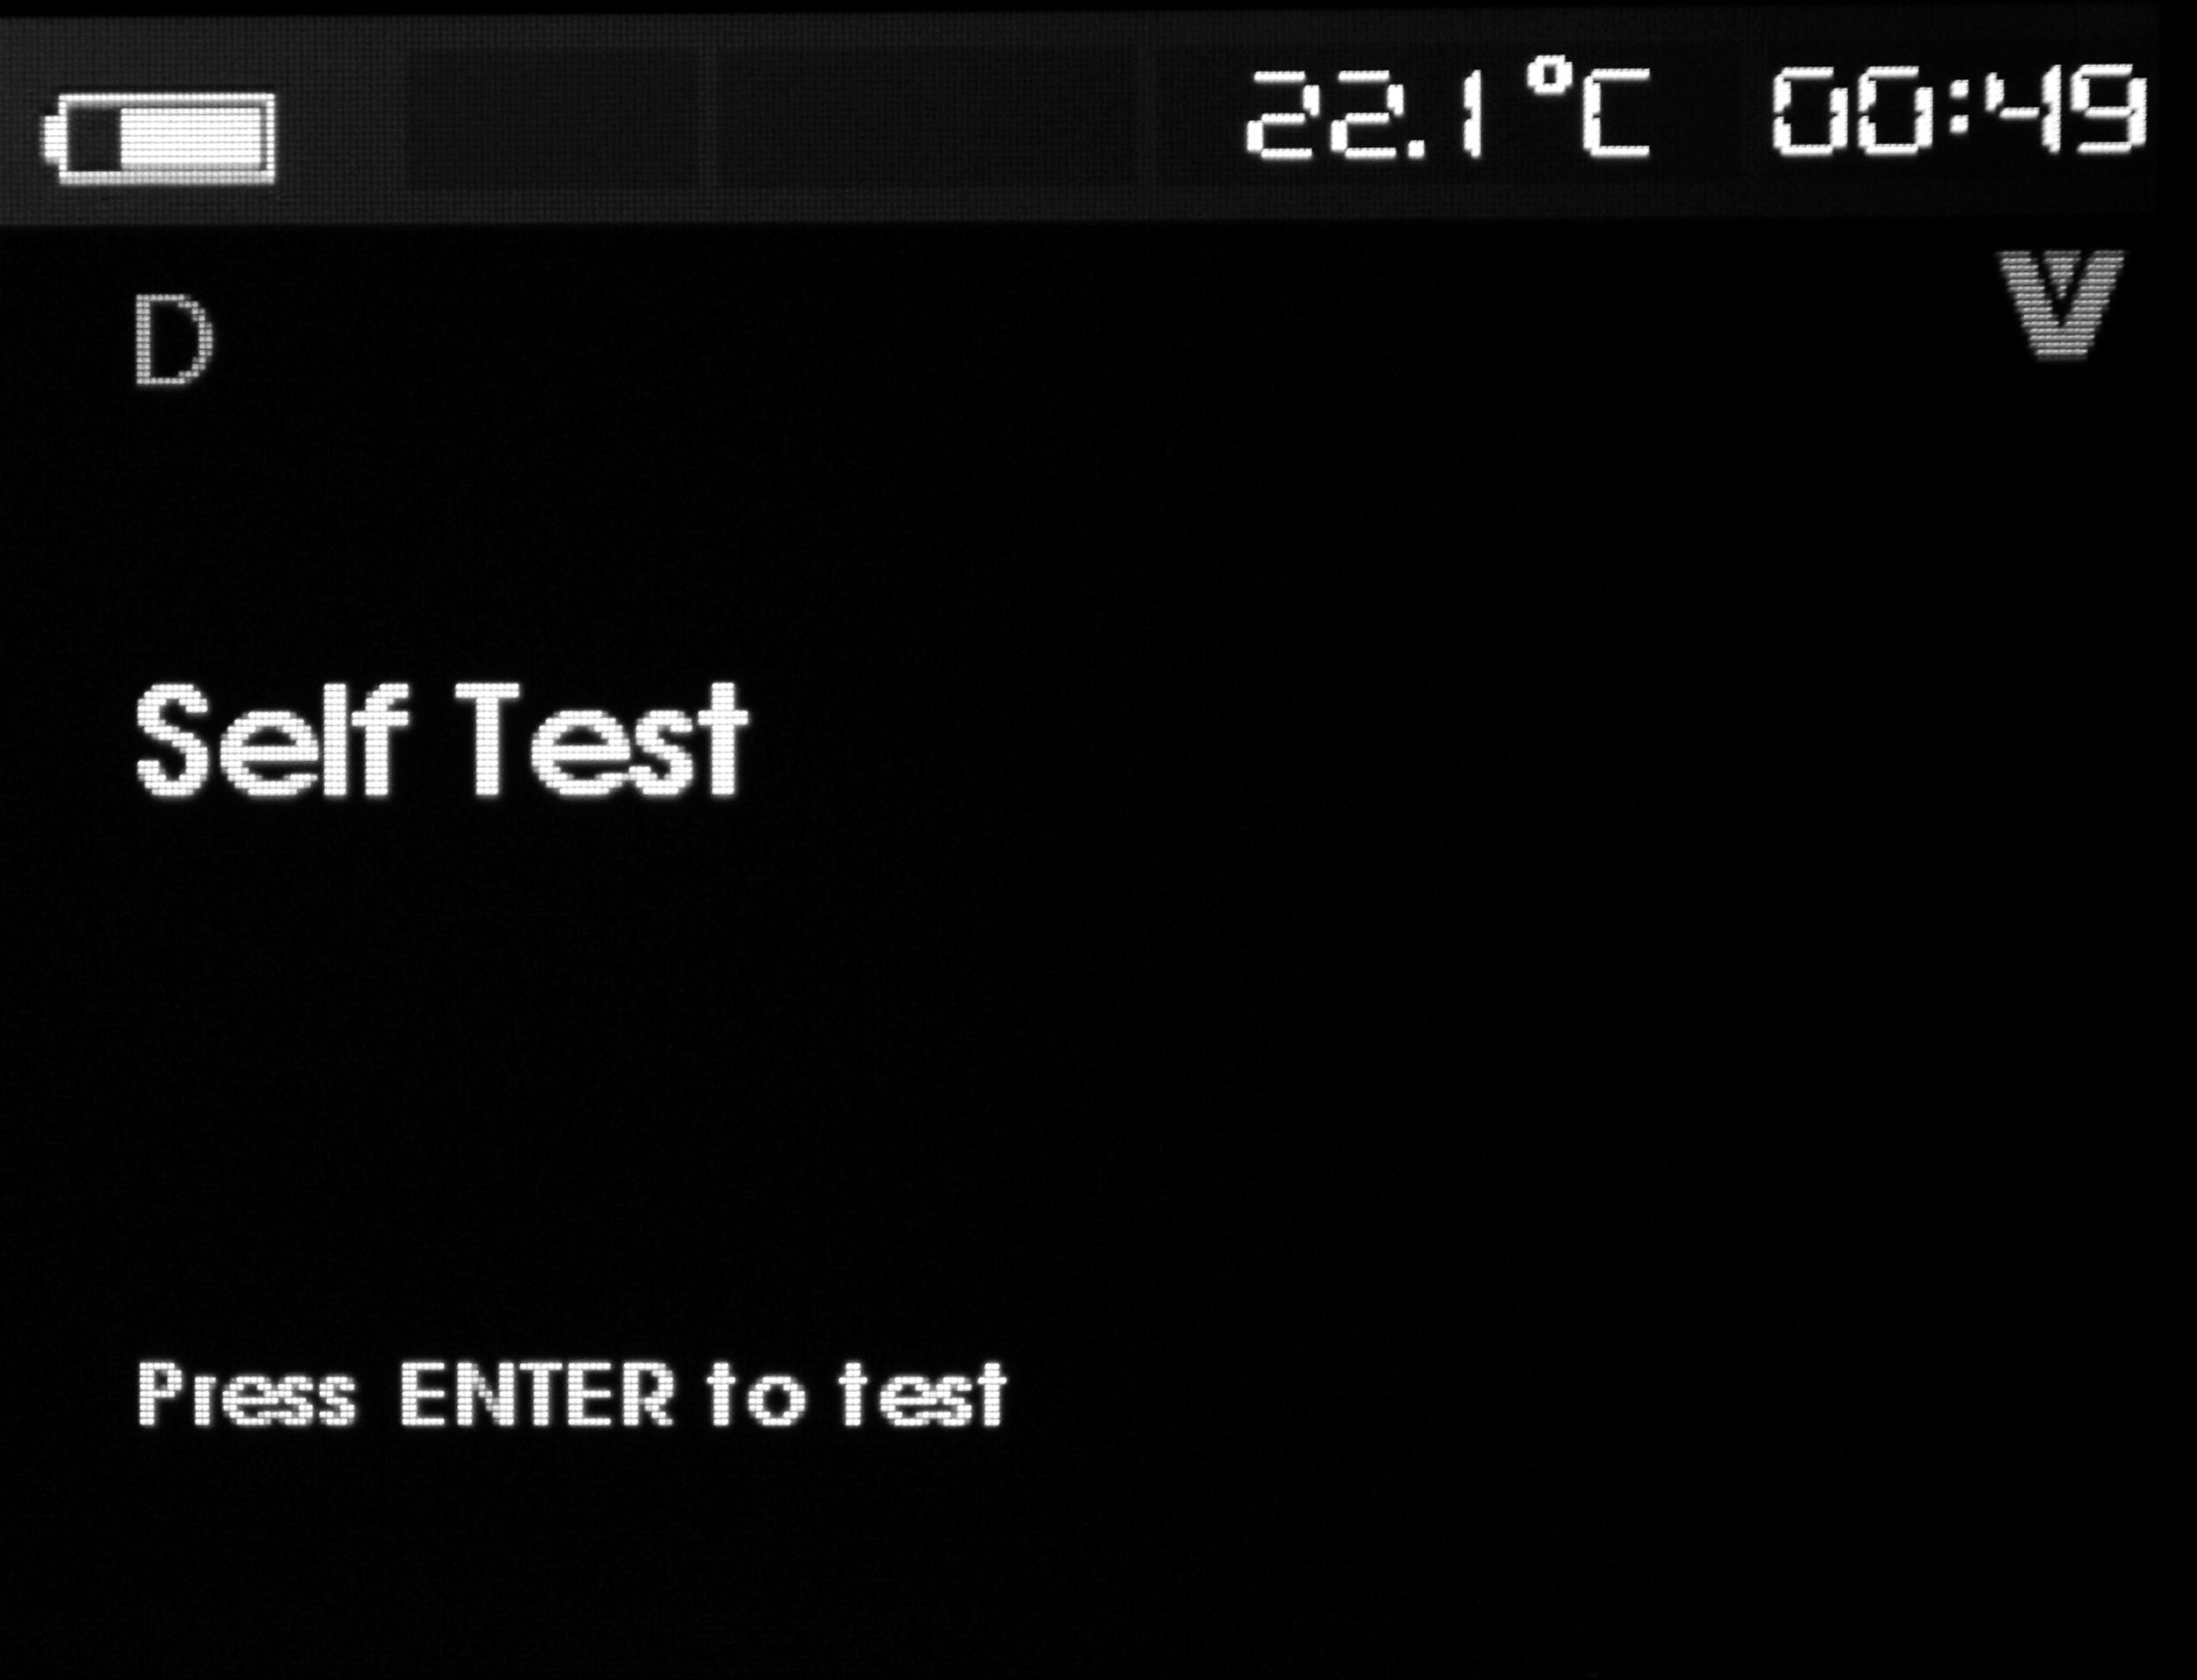
Repress ENTER to start self-diagnose. After the self-diagnose finishes, the screen will report right or wrong; the wrong screen includes four sub-screens, and switch the rotary key to check the contents in every screen. Press EXIT key, the screen will give a hint to change to auto mode, and then repress the EXIT key to exit from this function.
- Data logging and configuration logging
The fifth item in the function selection menu is data logging and configuration logging; The configuration logging and data logging are only available when connected in HART device. Use the rotary switch to select configuration logging or data logging.

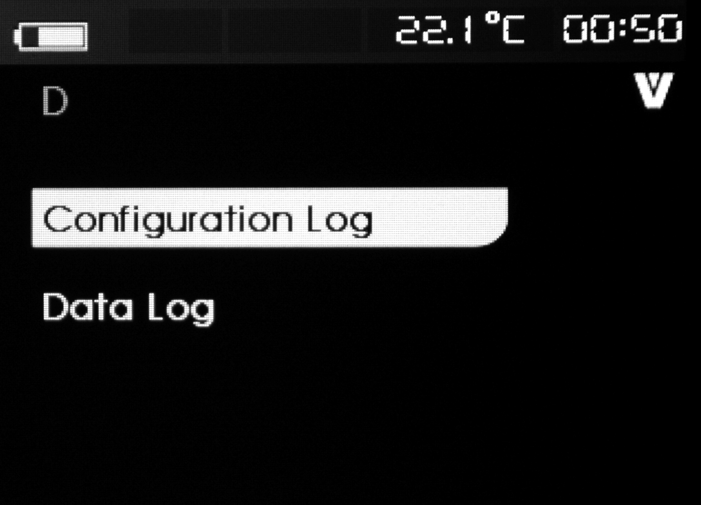
Configuration logging
The calibrator can store configuration data for twenty tags maximally for callout. And the stored configured data and device data shown in the screens are the same. The initial configuration logging screen spans among several screens, and will display all the stored tag logging. If there is unused storage location, the tag name part will display <empty>. Shown as figure:

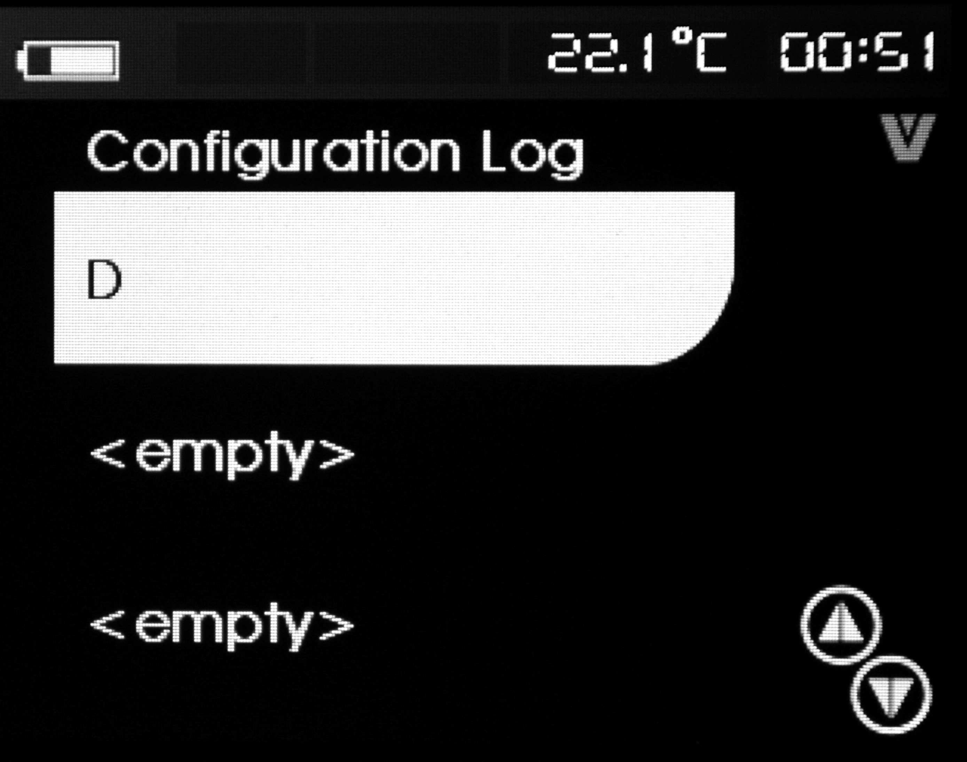
When selecting a storage location, you can save data or call data. Besides, you can delete data or send data to USB terminal or upload the data to your PC. Switch the rotary key to select the right storage location, press ENTER key to enter into the storage location submenu, as shown in figure:
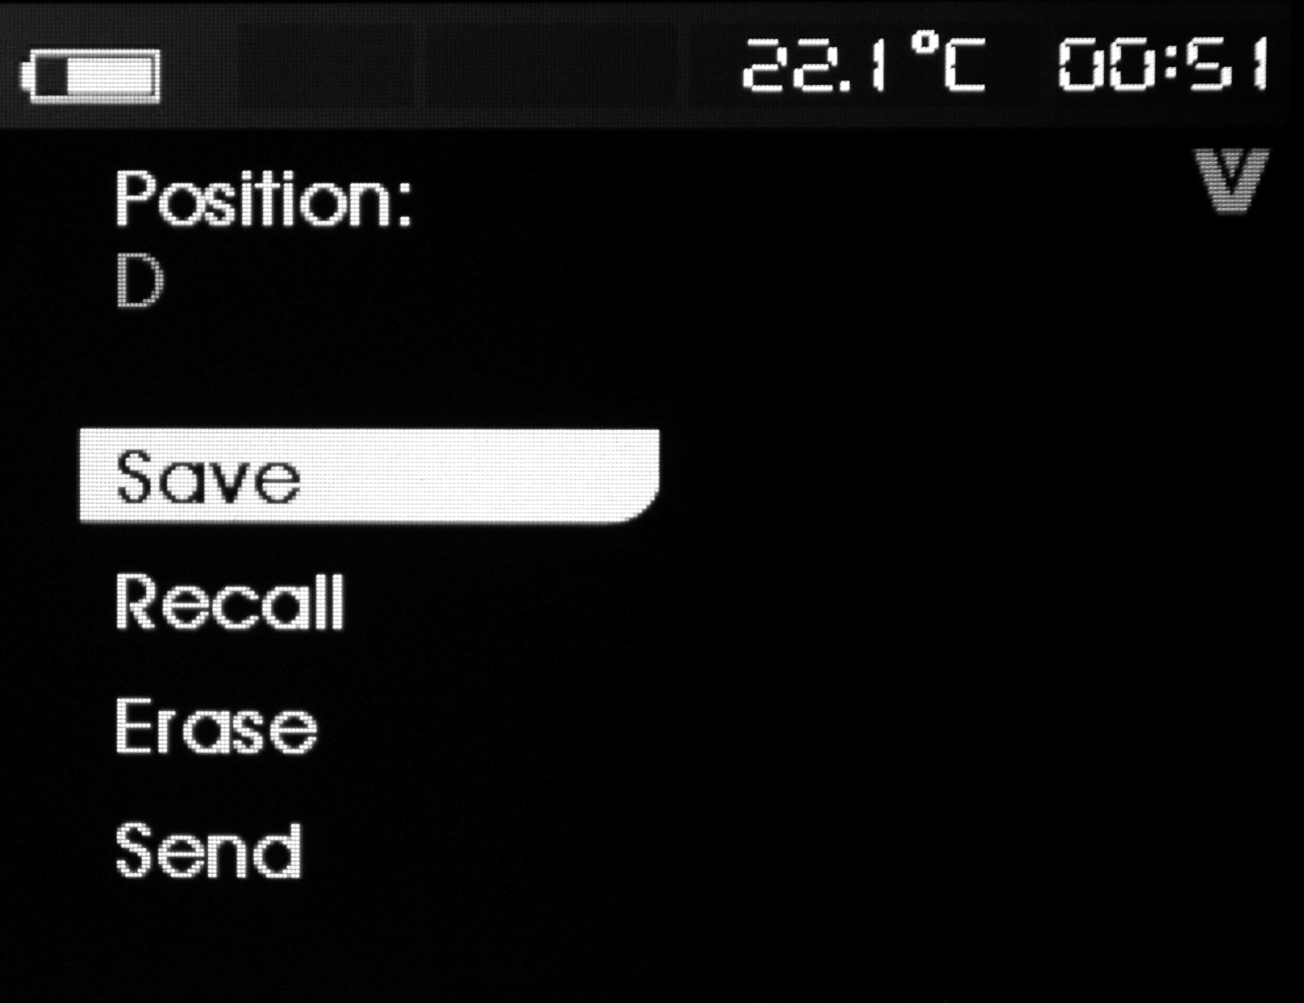
The number and content of the storage location are shown in the top. If there is unused storage location, the tag name part will display <empty>. Switch the rotary key to select the necessary function, press ENTER key to execute.
Saving operation:
If the storage location is null value, then the calibrator will save the device configuration data to the location.
If the storage location is in use, please confirm whether to replace the existing data to the current tab data before you save the data to the storage location.
Reading operation:
If the storage location is null value, the calibrator will send an error message.
If the storage location is in use, then the calibrator will display data in the same sequence as shown in the “device data” screen.
Clearing operation:
If the storage location is null value, the calibrator will send an error message.
If the storage location is in use, then the calibrator will confirm whether to conduct permanent deletion before deleting the data.
Sending operation:
If the storage location is null value, the calibrator will send an error message.
Data logging
This function is used for saving process data in a single tag in order to send to a PC with software. Data can be recorded in many conversations, but all conversation should come from the same HART device determined by the long tag name. You can select a different logging interval for every conversation. Every sample data includes the measured value, installed mA current and all four process variables. 1200 records are available. And every sample data uses one record. Every conversation uses two records for top data, for which the top data is common used by all data sample. The number for conversation is 1 to 99.The total number for recorded data is twice of the number difference by 1200 subtracting the conversation numbers of start and stop. As shown in following figure:

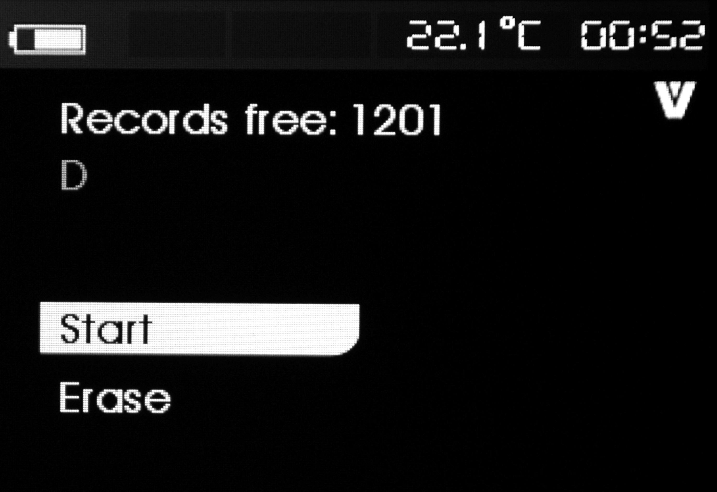
The number of free records is showed in the first row. If the data has been recorded, the tag number will be displayed below. Switch the rotary key to the needed function, and then press ENTER to execute.
Starting operation:
If there are no free records or free conversations, or the current HART device does not match with the recorded HART device, then the calibrator shows an error message. Otherwise the calibrator goes into the interval option showed in the Figure.

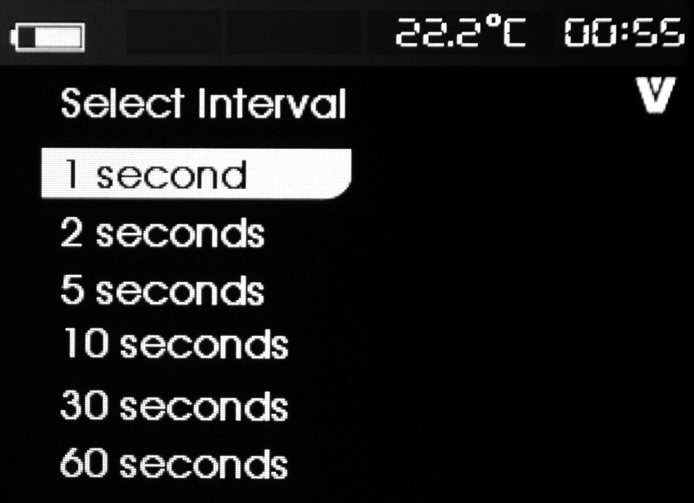
Switch the rotary key to the necessary interval logging interval. Press ENTER key and record according to the intervals. When the calibrator is recording, the screen shows the following figure to monitoring the process.

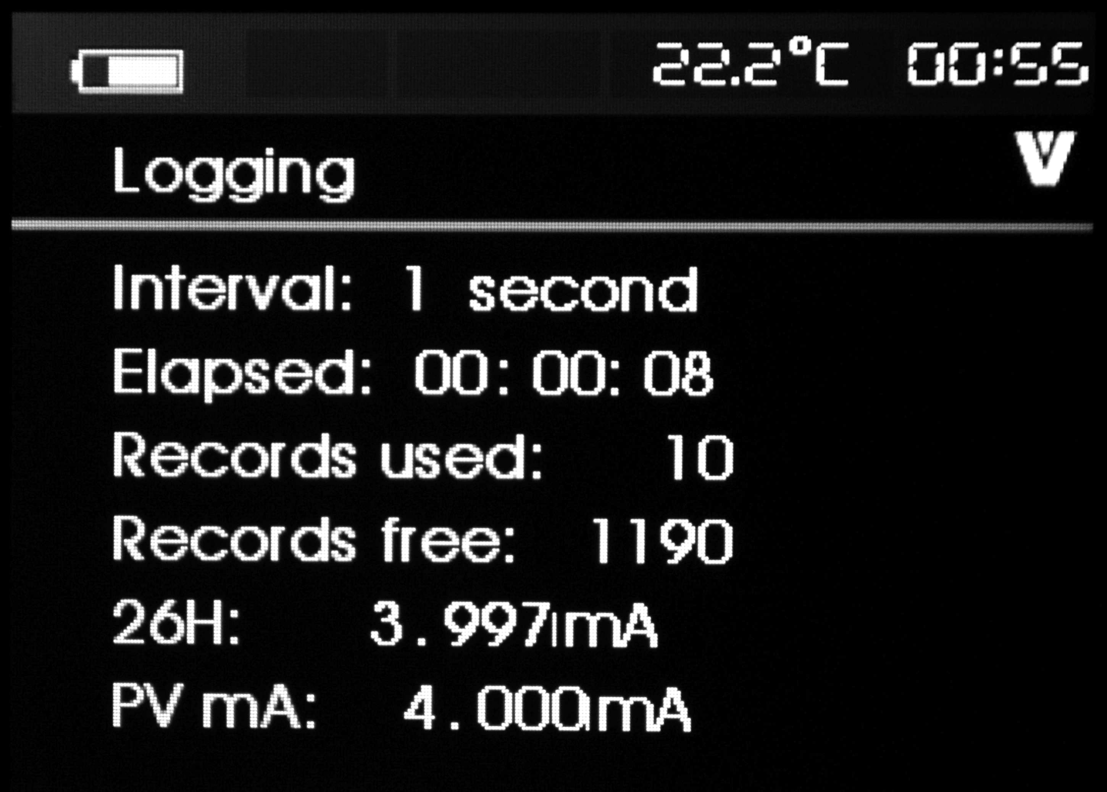
All the data item displayed are:
Top row logging is recording or has stopped. When the recorder is full, or before the calibrator is powered off due to the battery reaches the low voltage limits for auto power-off, the recording will stop automatically.
Interval time refers to the data selected by the previous option .Used time refers to the exhausted time when the logging starts, and data will refresh for every new sample. Used record refers to the total record number of all conversation until present. Free record refers to the total number for unused record. And will refresh for every new sample. 709H refers to present measured value and will refresh in frequency as high as possible. PV mA refers to the last measured value by HART device and will refresh in frequency as high as possible.
Clearing operation;
If there is no record data, the calibrator displays an error message. Otherwise the calibrator goes into the interval option showed in the Figure.
- Environmental Temperature Test
The calibrator can measure the surrounding environmental temperature, and displays it on the top right corner. After turning on the calibrator, LCD displays the temperature value and the unit in the top right corner.
- Data Storage
The calibrator can store data at any time, the maximum volume for stored data can reach 1200 items; Press the〔SAVE〕key to store the data; The storage item displays on the upper part of the screen.
- Maintenance
  - cleaning the calibrator
Warning
To avoid electrical shock or damaging the calibrator, serve the calibrator only by the replacement parts specified and never get water inside the case.

Caution
To avoid damaging the plastic lens and case, do not use solvents or abrasive cleansers. Clean the Calibrator with a soft cloth dampened with water or water and mild soap.

  - Calibration or Sending to the Service Center
Calibration, maintenance or repair work unmentioned in this manual should be undertaken by the experienced worker. If the calibrator operates abnormally, inspect the batteries first and replace them if necessary.
If you suspect that the calibrator has failed, review this manual to make sure you are operating it correctly. If the calibrator still fails to operate properly, pack it securely (in its original container if available) and forward it, postage paid, to the nearest Service Center. The company assumes NO responsibility for damage in transit.
The Company guarantees a rapid repair and maintenance and delivers the calibrator back as soon as possible. Please refer to the Warranty. If the warranty is due, you will be billed for the maintenance and repair work. If the calibrator or the pressure module is not within the Warranty range, you can contact the warranted service center for enquiring about the expenditure. Please refer to the Chapter “Contact Us” to find a warranted service center.

  - Replacement of Parts
All the types of parts are listed in Table 7, see Figure 23 as reference.

Figure 22 replacements of parts

Table 7. Replacement of parts
Item | Instruction | Quantity |  | Item | Instruction | Quantity
1 | Top panel | 1 |  | 18 | O-shape circle | 1
2 | Window protective film | 1 |  | 19 | O-shape circle | 1
3 | Trade Mark Frame | 1 |  | 20 | Bottom shell | 1
4 | O-shape circle | 1 |  | 21 | soft robber cover | 1
5 | Rubber Key | 1 |  | 22 | power reed | 4
6 | Panel Shield | 1 |  | 23 | battery | 1
7 | transparency window | 1 |  | 24 | O-shape circle | 1
8 | TFT screen | 1 |  | 25 | battery door | 1
9 | LCD Circuit Panel | 2 |  | Basic type | plastic screw | 2
10 | keyboard card | 1 |  | 27 | supporting panel | 1
11 | shielding case | 1 |  | 28 | industrial testing lead | 1
12 | O-shape circle | 1 |  | 29 | alligator clip | 2
13 | main-circuit board | 1 |  | 30 | testing probes | 1
14 | adaptive-circuit board | 1 |  | 31 | alligator clip | 1
15 | power circuit board | 1 |  | 32 | industrial testing lead | 1
16 | power circuit board | 1 |  | 33 | quick guide | 1
17 | communication window |  |  | 34 | Product DVD disk | 1

- Options
For more information about the options and its price, please contact the representative of the company. For information about relevant pressure module and its type (see Table 9 and Table 10). For information about the new pressure module, which isn’t listed in Table 9 and Table 10, please contact the representative of the company.
Table 8. Options
No. | Name of the Options | Mode
1 | PC communication convert module | Z070103-00
2 | Wired charger (DC5V) | P070003-00

- Technical index of Pressure Module Convertor and Compatibility
The source of pressure module may cause an overflow of 5-digits display or any improper selection of unit may cause failure reading due to low displayed value.
According to the range listed in the following table, the calibrator will display OL when exceeding the range (overload).
Table 9. Technical Index of Pressure Model
Type, range and accuracy of pressure module
Type of module | Range（kPa） | bar（bar） | psi（psi） | type of sensor | pressure datum | Overall accuracy（%）  0～50℃
VPM100KGS | 0～100kPa | 0～1bar | 0～15psi | Isolated, 316 stainless steel | gauge pressure | 0.05
VPM200KGS | 0～200kPa | 0～2bar | 0～30psi | Isolated, 316 stainless steel | gauge pressure | 0.05
VPM500KGS | 0～500kPa | 0～5bar | 0～72psi | Isolated, 316 stainless steel | gauge pressure | 0.05
VPM001MGS | 0～1MPa | 0～10bar | 0～150psi | Isolated, 316 stainless steel | gauge pressure | 0.05
VPM002MGS | 0～2MPa | 0～20bar | 0～300psi | Isolated, 316 stainless steel | gauge pressure | 0.05
VPM005MGS | 0～5MPa | 0～50bar | 0～725psi | Isolated, 316 stainless steel | gauge pressure | 0.05
VPM010MGS | 0～10MPa | 0～100bar | 0～1500psi | Isolated, 316 stainless steel | sealed gage pressure | 0.05
VPM020MGS | 0～20MPa | 0～200bar | 0～3000psi | Isolated, 316 stainless steel | sealed gage pressure | 0.05
VPM040MGS | 0～40MPa | 0～400bar | 0～5800psi | Isolated, 316 stainless steel | sealed gage pressure | 0.05
VPM060MGS | 0～60MPa | 0～600bar | 0～8700psi | Isolated, 316 stainless steel | sealed gage pressure | 0.05
VPM100KAS | 0～100kPa | 0～1bar | 0～15psi | Isolated, 316 stainless steel | Absolute pressure | 0.05
VPM200KAS | 0～200kPa | 0～2bar | 0～30psi | Isolated, 316 stainless steel | Absolute pressure | 0.05
VPM500KAS | 0～500kPa | 0～5bar | 0～72psi | Isolated, 316 stainless steel | Absolute pressure | 0.05
VPM001MAS | 0～1MPa | 0～10bar | 0～150psi | Isolated, 316 stainless steel | Absolute pressure | 0.05
VPM002MAS | 0～2MPa | 0～20bar | 0～300psi | Isolated, 316 stainless steel | Absolute pressure | 0.05
VPM005MAS | 0～5MPa | 0～50bar | 0～725psi | Isolated, 316 stainless steel | Absolute pressure | 0.05
VPM010MAS | 0～10MPa | 0～100bar | 0～1500psi | Isolated, 316 stainless steel | Absolute pressure | 0.05
VPM020MAS | 0～20MPa | 0～200bar | 0～3000psi | Isolated, 316 stainless steel | Absolute pressure | 0.05
VPM100KCS | -100～100KPa | -1～1bar | -15～15psi | Isolated, 316 stainless steel | compound pressure | 0.05
VPM200KCS | -100～200KPa | -1～2bar | -15～30psi | Isolated, 316 stainless steel | compound pressure | 0.05
VPM500KCS | -100～500KPa | -1～5bar | -15～72psi | Isolated, 316 stainless steel | compound pressure | 0.05
VPM001MCS | -0.1～1MPa | -1～10bar | -15～150psi | Isolated, 316 stainless steel | compound pressure | 0.05
VPM002MCS | -0.1～2MPa | -1～20bar | -15～300psi | Isolated, 316 stainless steel | compound pressure | 0.05

note:
1. pressure datum: gauge pressure, absolute pressure and compound pressure
2. pressure unit: supporting varieties of pressure unit(take calibrator main frame as reference)
3. resolution: 5 digits
4. measurement media: varieties of liquid and gas of 316 stainless steel are compatible
5. working temperature: 0 to 50℃
6. storage temperature: -10 to 60℃
7. sealed grade：IP54
8. pressure connector: M20×1.5mm external thread
9. module electronic connector：Binder 5-pole male
10. communication cable(option)：Binder 5-pole female to LEMO 5-pole male。
11. comply with electromagnetic standards（EMC）：EN61326-1：2006
12. comply with electromagnetic standards：IEC 61010-1：2000
13. measurement：about Ø30×130mm
14. weight：about 350g
16 Index
measured technique index [specified for a period of one year after calibration, at 23℃±5℃, 35～70%RH, accuracy =±（%reading +% range）].

F Function | Range | Range | Resolution | Accuracy | Remark
DCV | 50mV | -5.000mV～  55.000mV | 1μV | 0.01+0.01 | Input Resistance:  About 100MΩ
DCV | 500mV | -50.00mV～  550.00mV | 10μV | 0.01+0.01 | Input Resistance:  About 100MΩ
DCV | 5V | -0.5000V～  5.5000V | 0.1mV | 0.01+0.01 | Input Resistance: 1MΩ
DCV | 30V | -5.000V～  35.000V | 1mV | 0.01+0.01 | Input Resistance: 1MΩ
DCI | 50mA | -5.000mA～  55.000mA | 1μA | 0.01+0.01 | Shunt Resistance: 10Ω
OHM  （4W） | 500Ω | 0.00Ω～550.00Ω | 0.01Ω | 0.01+0.01 | 500Ω about 1mA simulation  5KΩ about 0.1mA simulation  Open Circuit Voltage：about 2.5V;  Does not include lead resistance;
OHM  （4W） | 5KΩ | 0.0000 KΩ～  5.5000KΩ | 0.1Ω | 0.01+0.01
FREQ | 50KHz | 3Hz～50.00000KHz | 0.01Hz | 0.01+0.00004 | Input Impedance：100 kΩ at least;  Sensitivity：3Vp-p minimum;  Duty Cycle: 50%.
FREQ | CPM | 180～3000000 CPM | 1CPM | ±2 bytes
TC | R* | 0°C～1767°C | 1°C | 0～500℃ : 1.8℃  500～1767℃ : 1.5℃ | By using ITS-90 temperature scale;  The accuracy does not include the error of internal temperature compensation caused by a sensor;
TC | S* | 0°C～1767°C | 1°C | 0～500℃ : 1.8℃  500～1767℃ : 1.5℃
TC | K | -100.0°～1372.0°C | 0.1°C | -100.0～0.0℃ : 1.2℃  0.0～1372.0℃ : 0.8℃
TC | E | -50.0°C～1000.0°C | 0.1°C | -50.0℃～0.0℃ : 0.9℃  0.0～1000.0℃ : 1.5℃
TC | J | -60.0°C～1200.0°C | 0.1°C | -60.0～0.0℃ : 1.0℃  0.0～1200.0℃ : 0.7℃
TC | T | -100.0°C～400.0°C | 0.1°C | -100.0～0.0℃ : 1.0℃  0.0～400.0℃ : 0.7℃
TC | N | -200.0°～1300.0°C | 0.1°C | -200.0～0.0℃ : 1.5℃  0.0～1300.0℃ : 0.9℃
TC | B* | 600°C～1820°C | 1°C | 600～800℃ : 2.2℃  800～1000℃ : 1.8℃  1000～1820℃ : 1.4℃
TC | L | -60.0°C～900.0°C | 0.1°C | -60.0～0.0℃ 0.7℃  0.0～900.0℃ 0.5℃
TC | U | -100.0°C～600.0°C | 0.1°C | -100.0～0.0℃ 0.7℃  0.0～600.0℃ 0.5℃
RTD | Pt100  385 | -200.0°C～800.0°C | 0.1°C | -200.0～0.0℃ : 0.5℃  0.0～400.0℃ : 0.7℃  400.0～800.0℃ : 0.8℃ | By using ITS-90 temperature scale;  The accuracy does not include the error of internal temperature compensation caused by lead resistance, three-wired and four wired.
RTD | Pt1000  385 | -200.0°C～630.0°C | 0.1°C | -200.0～100.0℃: 0.3℃  100.0～300.0℃ : 0.5℃  300.0～630.0℃ : 0.7℃
RTD | Pt200  385 | -200.0°C～630.0°C | 0.1°C | -200.0～100.0℃: 0.8℃  100.0～300.0℃ : 0.9℃  300.0～630.0℃ : 1.0℃
RTD | Pt500  385 | -200.0°C～630.0°C | 0.1°C | -200.0～100.0℃: 0.4℃  100.0～300.0℃ : 0.5℃  300.0～630.0℃ : 0.7℃
RTD | Cu10 | -100.0°C～260.0°C | 0.1°C | 1.8℃
RTD | Cu50 | -50.0°C～150.0°C | 0.1°C | 0.7℃
PULSE | 100000 cycles | 1～100000cycles | 1cycle | ±2 bytes | Take relevant index in frequency as reference
SWITCH |  | CLOSE / OPEN |  |  | About 1mA simulation  short circuit display CLOSE，  short circuit display OPEN；  Threshold value is about 200~300Ω
CONNECT | 500Ω | ≤ 50Ω sounds | 0.01Ω |  | 500Ω  About 1mA simulation
LOOP | 24 V |  |  | 10% | short circuit protection  Maximum current：22 mA  Maximum input voltage：30 V  DC source resistance：250Ω  Nominal value
Note：
- The valid range of the temperature in manual compensation is R、S、B graduation of the TC is 0～50°C.
- Measurement speed：twice / second
- Common mode rejection：50Hz /60Hz>120 dB, string mode rejection：50Hz/60Hz>60 dB
- Temperature co-efficiency：0.1 ×basic accuracy/℃ （temperature range <18℃ or >28℃）
- Inferior temperature compensation senor RJC，range of measured temperature -10～50°C. the accuracy of measured temperature ±0. 5℃ in 18 to 28°C, accuracy of other measured temperature is ±1℃。Cold compensation time: 10S/ each。
- V、Ω、Hz input terminals and the maximum voltage applied between COM terminals is: 30Vpk
- Maximum current of mA terminals is：100m. input protection of mA terminals：100mA/250Vfas-melt
- Built-in optional 250 Ω HART loop circuit, not necessary to carry load resistance separately（only available for HART type）。
Source technical index [specified for a period of one year after calibration, at 23℃±5℃, 35～70%RH, accuracy =±（%reading +% range）].
Function | range | input set range | resolution | accuracy | remark
DCV | 100mV | -10.000～110.000mV | 1μV | 0.01+0.01 | maximum source current 0.5mA
DCV | 1V | -0.10000～1.10000V | 10μV | 0.01+0.01 | maximum source current 2mA
DCV | 10V | -1.0000～11.0000V | 0.1mV | 0.01+0.01 | maximum source current 5mA
DCmA | 30mA | 0.000～33.000mA | 1μA | 0.01+0.01 | In 33 mA,  Max load 1KΩ resistance  simulate convertor,  External power: 5～28V
 | 400Ω | 0.00～400.00Ω | 0.01Ω | 0.01+0.01 | Simulate current: ±0.5~3mA  Simulate current: ±0.1~0.5mA, add 0.1Ω additional error.  The accuracy does not include the lead resistance.
 | 4KΩ | 0.0000～4.0000 KΩ | 0.1Ω | 0.01+0.01 | ±0.05~0.3mA simulate current, The accuracy does not include the lead resistance.

TC | R* | 0°C～1767°C | 1°C | 0～100℃ : 1.5℃  100～1767℃: 1.2℃ | By using ITS-90 temperature scale;  The accuracy does not include the error of cold end compensation.
TC | S* | 0°C～1767°C | 1°C | 0～100℃ : 1.5℃  100～1767℃: 1.2℃
TC | K | -200.0°C～1372.0°C | 0.1°C | -200.0～-100.0 : 0.6℃  -100.0～400.0℃:0.5℃  400.0～1200.0℃:0.7℃  1200.0～1372.0 : 0.9℃
TC | E | -200.0°C～1000.0°C | 0.1°C | -200.0～-100.0 : 0.6℃  -100.0～600.0℃:0.5℃  600.0～1000.0℃:0.4℃
TC | J | -200.0°C～1200.0°C | 0.1°C | -200.0～-100.0 : 0.6℃  -100.0～800.0℃: 0.5℃  800.0～1200.0℃:0.7℃
TC | T | -250.0°C～400.0°C | 0.1°C | -250.0～400.0℃: 0.6℃
TC | N | -200.0°C～1300.0°C | 0.1°C | -200.0～-100.0℃:1.0℃  -100.0～900.0℃: 0.7℃  900.0～1300.0℃:0.8℃
TC | B* | 600°C～1820°C | 1°C | 600～800℃ : 1.5℃  800～1820℃: 1.1℃
TC | L | -200.0°C～900.0°C | 0.1°C | -200.0～0.0℃ 0.7℃  0.0～900.0℃ 0.5℃
TC | U | -200.0°C～600.0°C | 0.1°C | -200.0～0.0℃ 0.7℃  0.0～600.0℃ 0.5℃

RTD | Pt100  385 | -200.0°C～800.0°C | 0.1°C | -200.0～0.0℃ : 0.3℃  0.0～400.0℃ : 0.5℃  400.0～800.0℃: 0.8℃ | By using ITS-90 temperature scale;  Pt100、Cu50、Cu10 simulate current is ：  ±0.5~3mA  simulate current is ：±0.1~0.5mA，add 0.5℃ additional error  Pt200、Pt500、Pt1000 simulate current ±0.05~0.3mA  The accuracy does not include lead resistance
RTD | Pt1000  385 | -200.0°C～630.0°C | 0.1°C | -200.0～100.0℃: 0.2℃  100.0～300.0℃: 0.5℃  300.0～630.0℃: 0.7℃
RTD | Pt200  385 | -200.0°C～630.0°C | 0.1°C | -200.0～100.0℃: 0.8℃  100.0～300.0℃ : 0.9℃  300.0～630.0℃ : 1.0℃
RTD | Pt500  385 | -200.0°C～630.0°C | 0.1°C | -200.0～100.0℃: 0.4℃  100.0～300.0℃ : 0.5℃  300.0～630.0℃ : 0.7℃
RTD | Cu10 | -100.0°C～260.0°C | 0.1°C | 1.8℃
RTD | Cu50 | -50.0°C～150.0°C | 0.1°C | 0.6℃
FREQ | 100Hz | 1.00Hz～110.00Hz | 0.01Hz | ±2 bytes | Sensitivity: 1～11 Vp-p±5％ reading +0.5V  Duty Cycle: 50%  Load>100KΩ  ：3Vp-p minimum;  Duty Cycle: 50%.
FREQ | 1KHz | 0.100KH～1.100KHz | 1Hz | ±2 bytes
FREQ | 10KHz | 1.0KHz～11.0KHz | 0.1KHz | ±2 bytes
FREQ | 50KHz | 10KHz~50KHz | 2KHz | ±5 byes
FREQ | CPM | 60～1200CPM | 1CPM | ±2CPM

PULSE | 100Hz | 1～100000cycles | 1cyc | ±2 bytes | Sensitivity: 1～11 Vp-p±5％ reading +0.5V  Duty Cycle: 50%  Load>100KΩ
PULSE | 1KHz
PULSE | 10KHz
SWITCH | 100Hz | 1.00Hz～110.00Hz | 0.01Hz | ±2 bytes | field effect switch  maximum current/voltage：+28 V/50mA
SWITCH | 1KHz | 0.100KHz～1.100KHz | 1Hz | ±2 bytes | field effect switch  maximum current/voltage：+28 V/50mA
SWITCH | 10KHz | 1.0KHz～11.0KHz | 0.1KHz | ±2 bytes | field effect switch  maximum current/voltage：+28 V/50mA
SWITCH | 50KHz | 10KHz~50KHz | 2KHz | ±2 byts | field effect switch  maximum current/voltage：+28 V/50mA

Notes ：
- Temperature co-efficiency: 0.1 ×basic accuracy/ ℃ （temperature range <18℃ or >28℃）
- Inferior temperature compensation sensor RJC, measured temperature range -10～50°C, compensation error ≤±0. 5℃
- Maximum voltage applied between the input terminals and the earth is: 30Vpk
- Maximum soured current: about 25mA
- The valid range of the temperature in manual compensation is R、S、B graduation of the TC is 0～50°C.

Measured and sourced voltage
pressure  PRESS | range and accuracy | resolution | Applicable to pressure module in VPM series, provides modules used for gauge pressure, vacuum pressure, absolute pressure and high pressure; see Pressure Module for detailed technical index.
pressure  PRESS | see pressure module | display in five digits

17 NOTES FOR THE MANUAL
- The present operation instruction is subject to change without notice.
- The content of the operation instruction is regarded as correct. Whenever any user finds its mistakes, omission, etc., he or she is requested to contact the manufacturer.
- The Company is not liable for any accident and hazard arising from the customer misuse or inadvertent operation.
- The functions described in this operation instruction should not be used as grounds to apply this product to a particular purpose.

